Make it Fun with Games, Activities, Science, & Snacks!
Snack Idea: Make Jonah and the Whale Jello Aquarium!
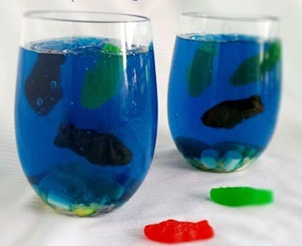
Ingredients:
2 (6 oz) Jello Berry Blue Flavor or Starburst Blue Raspberry Gelatin
8 cups water
4 (19 oz) plastic cups
Swedish fish
Gummi Bear ( that’s Jonah!)

Optional and fun additions: green licorice for seaweed, marshmallows for reef. Get creative!
Instructions: Prepare Jell-o according to instructions and let cool completely. Place Jell-o in the refrigerator and allow it to almost set.
Spoon Jell-o one tablespoon at the time and begin adding swedish fish and other items to Jell-o. Cover all with Jell-o. Place cups in the refrigerator to complete setting up. Enjoy!

