Make Fish Slime!
Hint for Parents: It’s super simple and fun to make!
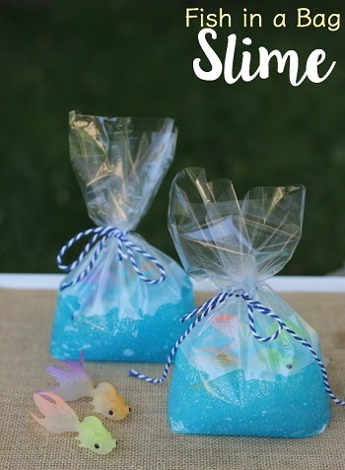
Supplies Needed: Supplies available at Amazon
- Plastic fish. Liquid Starch, Blue glitter glue, Treat bags, Twine or Ribbon
Fish Slime Directions:
Add 1/4 cup of water to a bowl. Next add one container of glitter glue to your bowl (about 1/2 cup or basically the entire 6 oz container of glue). Stir very briskly or use a whisk. Stirring gently won’t incorporate the water into the glue- you don’t want the water to remain separate as you can see above. Stirring with a fork or whisk will bring both ingredients together.
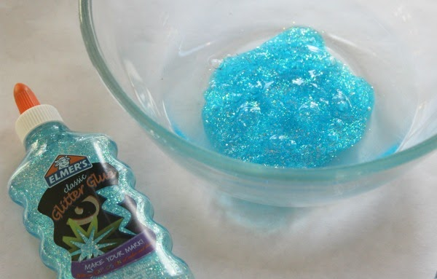
Add 1/2 cup liquid starch to your mixture and again stir well to incorporate. Allow mixture to sit for 5-10 minutes, which allows the water to be incorporated and makes it easier to handle.
Knead the slime with your hands until it feels bouncy and stretchy. Place the slime in a treat bag in a ball. The slime will mold to a big blob at the bottom. Place the fish in the slime in the front of the bag and on the top after putting the slime in the bag. Tie with the twine or ribbon and you’re done! Have fun!

