GEORGE MONK

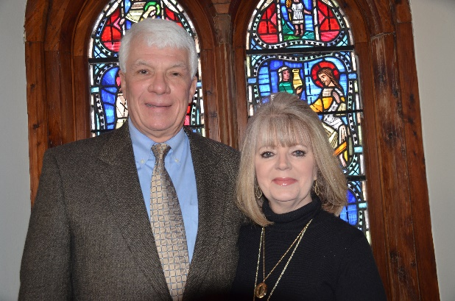

Family.

I am married to Cindy. We are blessed to have our children Ben (Fairhope), Andrew (Milton, Georgia) and Kristen (Houston) each of whom have two children of their own, our "little nuggets" as we refer to them. Cindy and I also have BadRosie (our Snorkie) named appropriately.

Length of Time at Grace Episcopal Church.

Since birth, a long time ago.

My Favorite Thing about Grace Episcopal Church.

It's unquestionable beauty, and its historical leadership role among our local faith-based organizations in community affairs and relations.

My Parish Activities.

Over time (a long time) I have served as an Acolyte in my youth and thereafter as Acolyte/Trainer Master a number of years ago. I taught the Youth Confirmation Class for several years, and I have served on the Vestry and as Junior Warden and Senior Warden.

If Applicable, Experiences at Other Churches.

Well, there was the Christmas Eve service at St. John's in Denver, and the Christmas Eve service at St. Martins in Houston which were glorious experiences. Regardless, my greatest experiences have been at Grace Episcopal Church. I have certainly attended other churches but never joined or had any thoughts of joining. I love our liturgy.

Professional History.

I have practiced law in our town for 45 years with four or so years in the middle when I "wandered in the wilderness" as City Manager of the City of Anniston only to return to where I should have been all along.

Other Interests.

Reading, current events, yardwork (Cindy calls it gardening, it's work) and……. Alabama football, of course! People……..I enjoy their life stories and various views.

Why I Would Like to Serve as a Vestry Member.

My hope is to be a reminder of our Anglican traditions, to ensure that our Parish remains a vibrant, broad based and loving body, financially secure and spiritually sound. I would like to assist Father Wally in his ministry.

