Alli Waltz

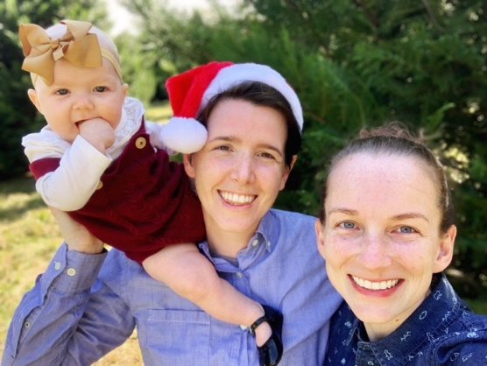

Family. I am married to Lauren Waltz. We live at Booger Hollow Farm with our dog, cat, goats, chickens, and honeybees. We welcomed our baby girl, Avery Jane, to the Hollow in June of 2020!

Length of Time at Grace. I have been attending Grace since Fall of 2016.

Why I came to Grace. I started attending Grace after participating with the Beans and Rice ministry on a random Saturday. Lauren invited me to the volunteer opportunity and then Diane Phillips invited me to church and then refused to let me say no.

My favorite thing about Grace Episcopal Church. I attended my first service because Diane wouldn’t let me say no, but I stayed because of the community. Grace roots me into this community and its people have made me feel at home.

My Parish Activities. Current: Ushering, Altar Guild, LobsterFest, Host Annual Parish Party, Stewardship Committee, Newcomers/Evangelism Committee. Past: Brass Polishers, Wednesday Night Cook Team, assisted with EYC, Foothills, alternate for Bishop Election/Diocesan Convention 2020, attended Rooted in Jesus Conference 2020, Beans and Rice Preparation.

Professional History. I graduated law school in 2016 and spent two years as corporate counsel for my family’s business before sitting for the Alabama bar in 2018. Upon being admitted to practice in Alabama, I started working at Stedham Law Firm. I also spent a year and a half at Interfaith Ministries as the co-director of Emergency Assistance. Currently I am pursuing a dual master’s degree in public administration and community planning from Auburn University.

Other Interests. Running, Cycling, Swimming, Reading, Education for Ministry (EFM), Learning Piano (I can play Twinkle, Twinkle, Little Star and Mary Had A Little Lamb), and Traveling (Spain, Galapagos Islands, Finland, Panama, England, France, Netherlands, Belgium, Ireland)

Why I would like to serve as a Vestry Member. I think it is everyone’s duty to offer themselves in service of the church in whatever way they are able. I believe I can offer a unique perspective as someone in their 30s and as the parent of a newborn to a church that is trying to attract more young-ish people.

