BETTY YARBROUGH

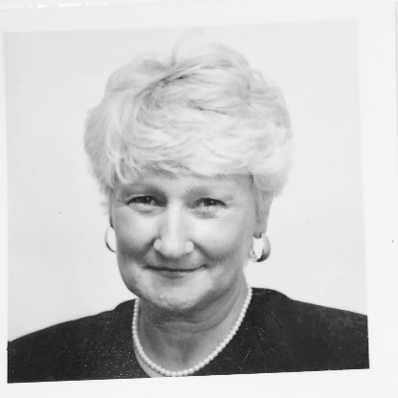

FAMILY: Daughter, Donna in Anniston with Jason, plus my grandchildren, Holly, Kallie and Hunter... Son, Don in Oregon with Lisa and 3 more grandchildren, Adam, Emma and Aaron

LENGTH OF TIME AT GRACE: 29 years

WHY I CAME TO GRACE: Family Denomination-Methodist, Married Denomination-
Baptist; Big life change in 1991...decided to visit a church of each major denomination
in Anniston and allow God’s guidance in my church choice for the first time in my life...which led me to Grace, The Episcopal Faith and my new church family.

MY FAVORITE THINGS ABOUT GRACE: The Episcopal Liturgy, The beautiful, worshipful Sanctuary, and the warm and caring People.

MY PARISH ACTIVITIES: Served over the years as Vestry Member, Lector, Adult Sunday School Teacher, Children’s Choir Leader, Lobsterfest, Breakfast Team

PROFESSIONAL HISTORY: Second Grade Teacher-7 years and Speech/ Language Pathologist in Private Practice from 1977 to current date

OTHER INTERESTS: Family, Friends, Reading, Writing, Tennis, Nature, Traveling

WHY I WOULD LIKE TO SERVE AS A VESTRY MEMBER: I’ve declined for a long time, citing work schedule and any number of “valid” reasons. Pandemic 2020 has been a stressful yet soul searching time for me. My daily prayer has been for The Lord to allow me to be more open to where I might be needed to serve in this trimester of my life. This is why I told Pam I was willing to allow her to submit my name as a nomination for our Vestry.

