the

coloring book for all ages

a symbol shaped like a shield, variously round, octagonal, triangular, or somewhat
heart-shaped.
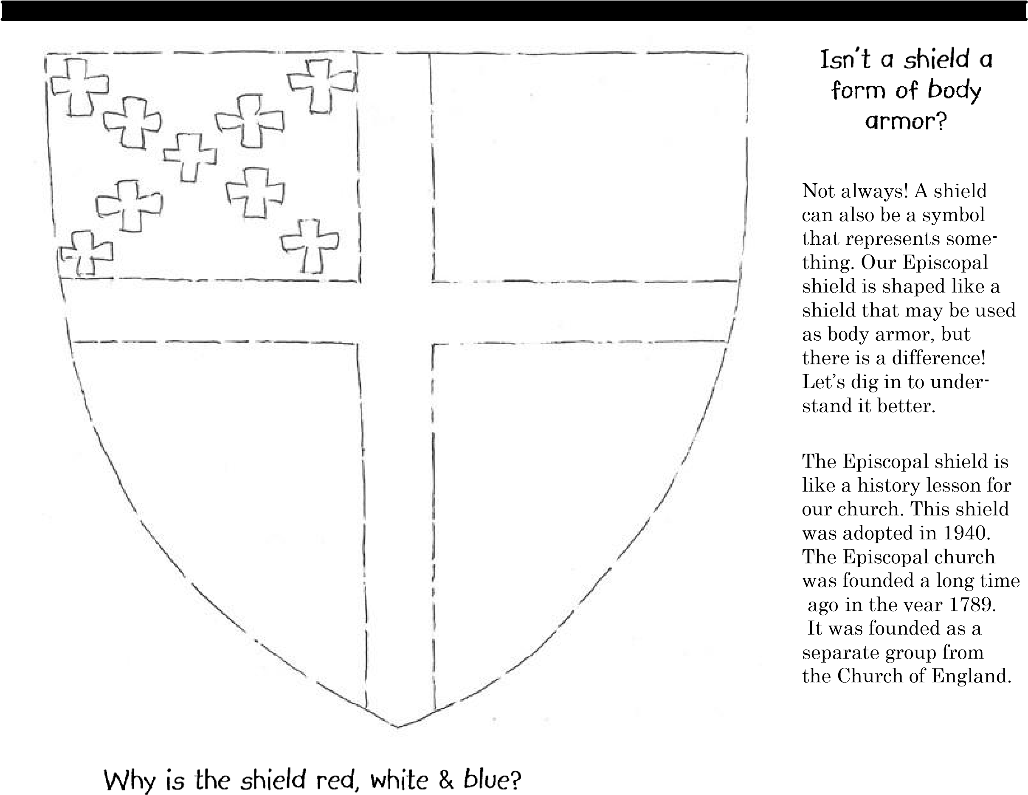
To show that we are an American church, the shield is made up of the same colors as our
American flag—red, white, and blue. Did you know that many of our presidents were Episcopalians? George Washington, James Madison, Franklin D. Roosevelt, Gerald Ford & George H.W. Bush...
just to name a few.

The white field with a red cross is St. George’s Cross. St. George was the patron saint of the Church of England (we must remember our roots!). Then, there are the nine white miniature crosses. These are not just symbols of our faith; they symbolize the nine original dioceses established in 1789.
The “X” formation is in remembrance of St. Andrew’s Cross. St. Andrew was the patron saint of Scotland. This reminds us that Scotland ordained Samuel Seabury as the first American Bishop in 1784.

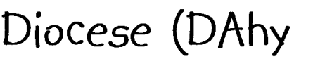

an ec
clesiastical district under the jurisdiction of a bishop

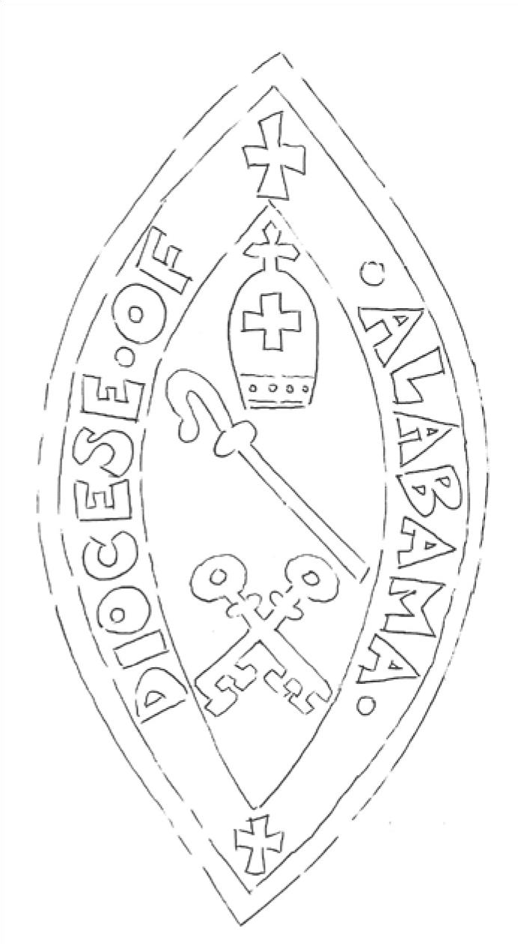
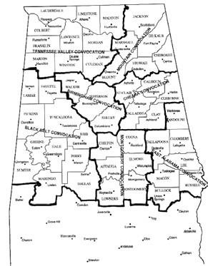
A

diocese is a

geographical
area.

Our geographical area is named th
e

Dio
cese of Alabama.

Our diocese is divided into 7
convocations which start in

the northern most tip of the
state and extend

down to right

below Selma. A convocation is like what a county

is to a state.

Our convocations have 92 different churches,

chaplaincies &

worshiping communities, all which make up
our diocese.

Our diocese is named the

Diocese of Alabama
,

but it only

includes a portion of our state! In

the 1970’s the southern part of the

state split off into another Diocese.

They are now called the

Diocese of

the Central Gulf Coast

which

includes counties south of

Montgomery and the

panhandle of Florida.

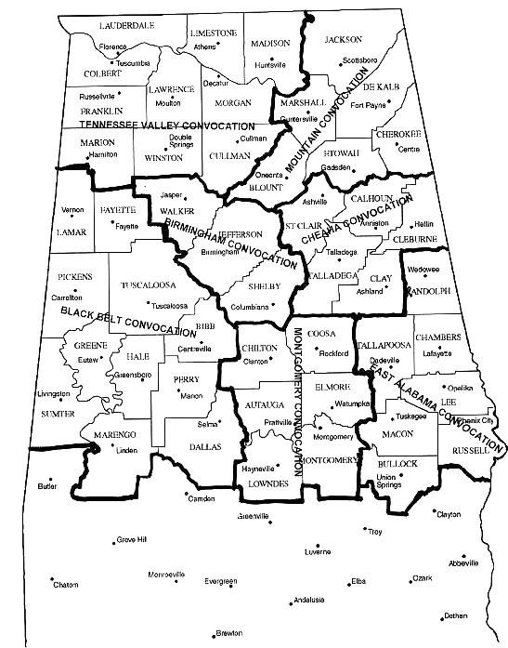
an ecclesiastical district under the jurisdiction of a bishop

Check out this map of the Diocese of Alabama. First, find
your convocation.

For kids:
:

Outline your convocation in

BLUE
.

C
olor your
county in
RED
.

Color all of the other counties of your convocation

YELLOW
.
Draw a
GREEN STAR

where you
think your church lies within your county.

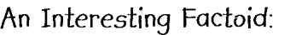
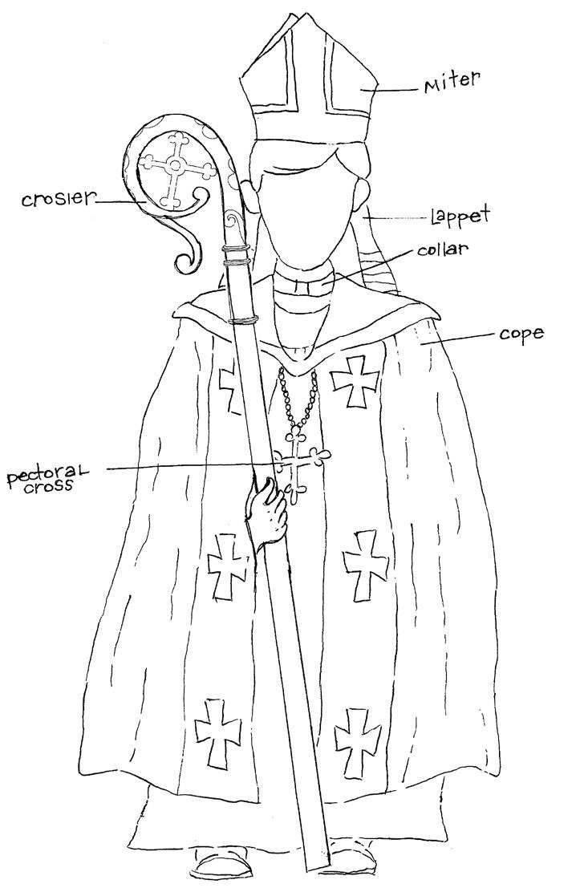
a person who supervises a number of local churches or a diocese, being in the Greek, Roman Catholic, Anglican, and other churches - a member of the highest order of the ministry

Bishops are often referred

to as “shepherds” since

the Greek word for bishop,

Episkopos

, is translated

“overseer” or “to watch

over”.

The bishop is the chief priest (also known as the shepherd) of our diocese. Bishops are charged with serving as a pastor to our clergy and the shepherd that protects our faith and the word of God through our church. Our bishop is the authority of our diocese to act in Christ’s name. Bishops visit each church to baptize and confirm members.

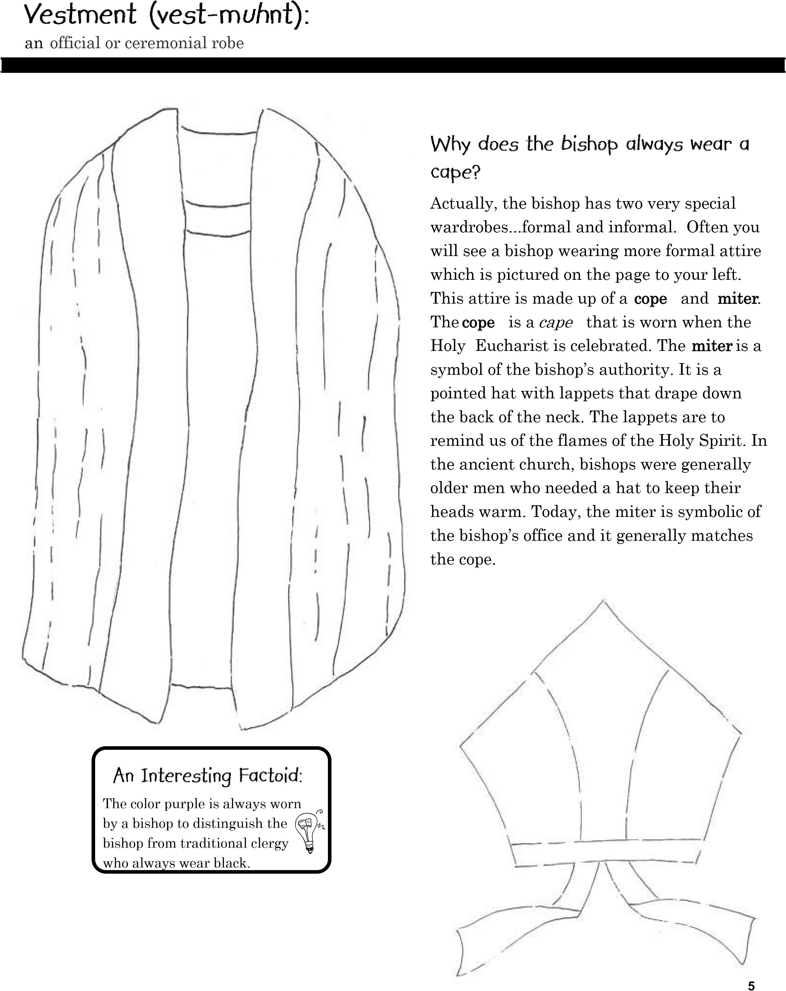
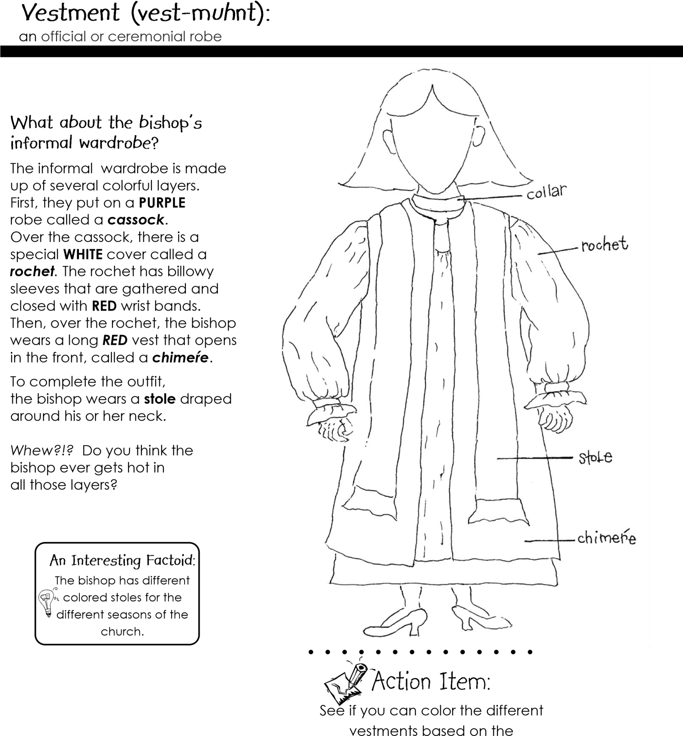
description above.

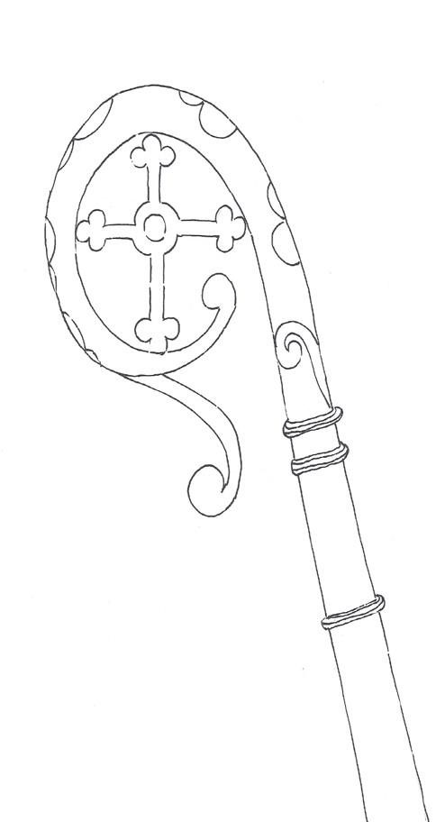
a staff surmounted by a crook or cross, carried by bishops as a symbol of pastoral office
A bishop carries a crosier to symbolize that he

is the shepherd of his flock. The crosier’s shaft is

a walking stick symbolizing a bishop’s call to

travel ne
ar and far to preach the Gospel. The

curled end of the crosier symbolizes the

bishop’s role in guiding the flock and the point
-

ed end symbolizes the bishop’s role in defend
-

ing the flock.

a figure of two intersecting lines resembling the historical structure upon which persons such as Jesus were put to death - used as a Christian emblem, badge, etc.
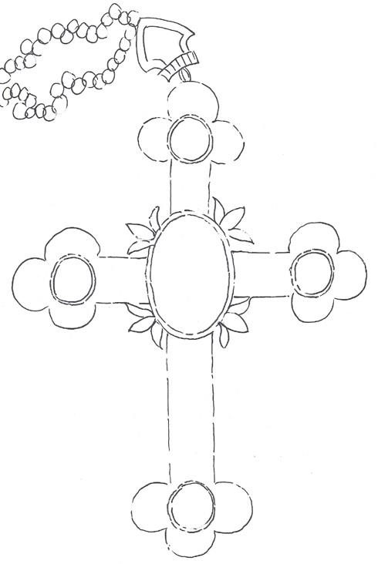

This is the actual size of th

e

bishop’s pectoral cross!

The pectoral cross is usually a big cross hanging from the neck by a cord or chain that reaches far down on the chest. It is worn by the bishop and is different from the small crosses worn on necklaces by many Christians. Most pectoral crosses are made of precious metals (platinum, gold or silver) and semiprecious gems.
The pectoral cross is distinguished by it size (up to six inches...WOW!) and is worn in the center of the chest below the heart. Do you think you could wear a cross that big? It would be really heavy!

a typically circular band of metal or other durable material, especially one of gold or other precious metal, often set with gems, for wearing on the finger as an ornament, a token of betrothal or marriage, etc.
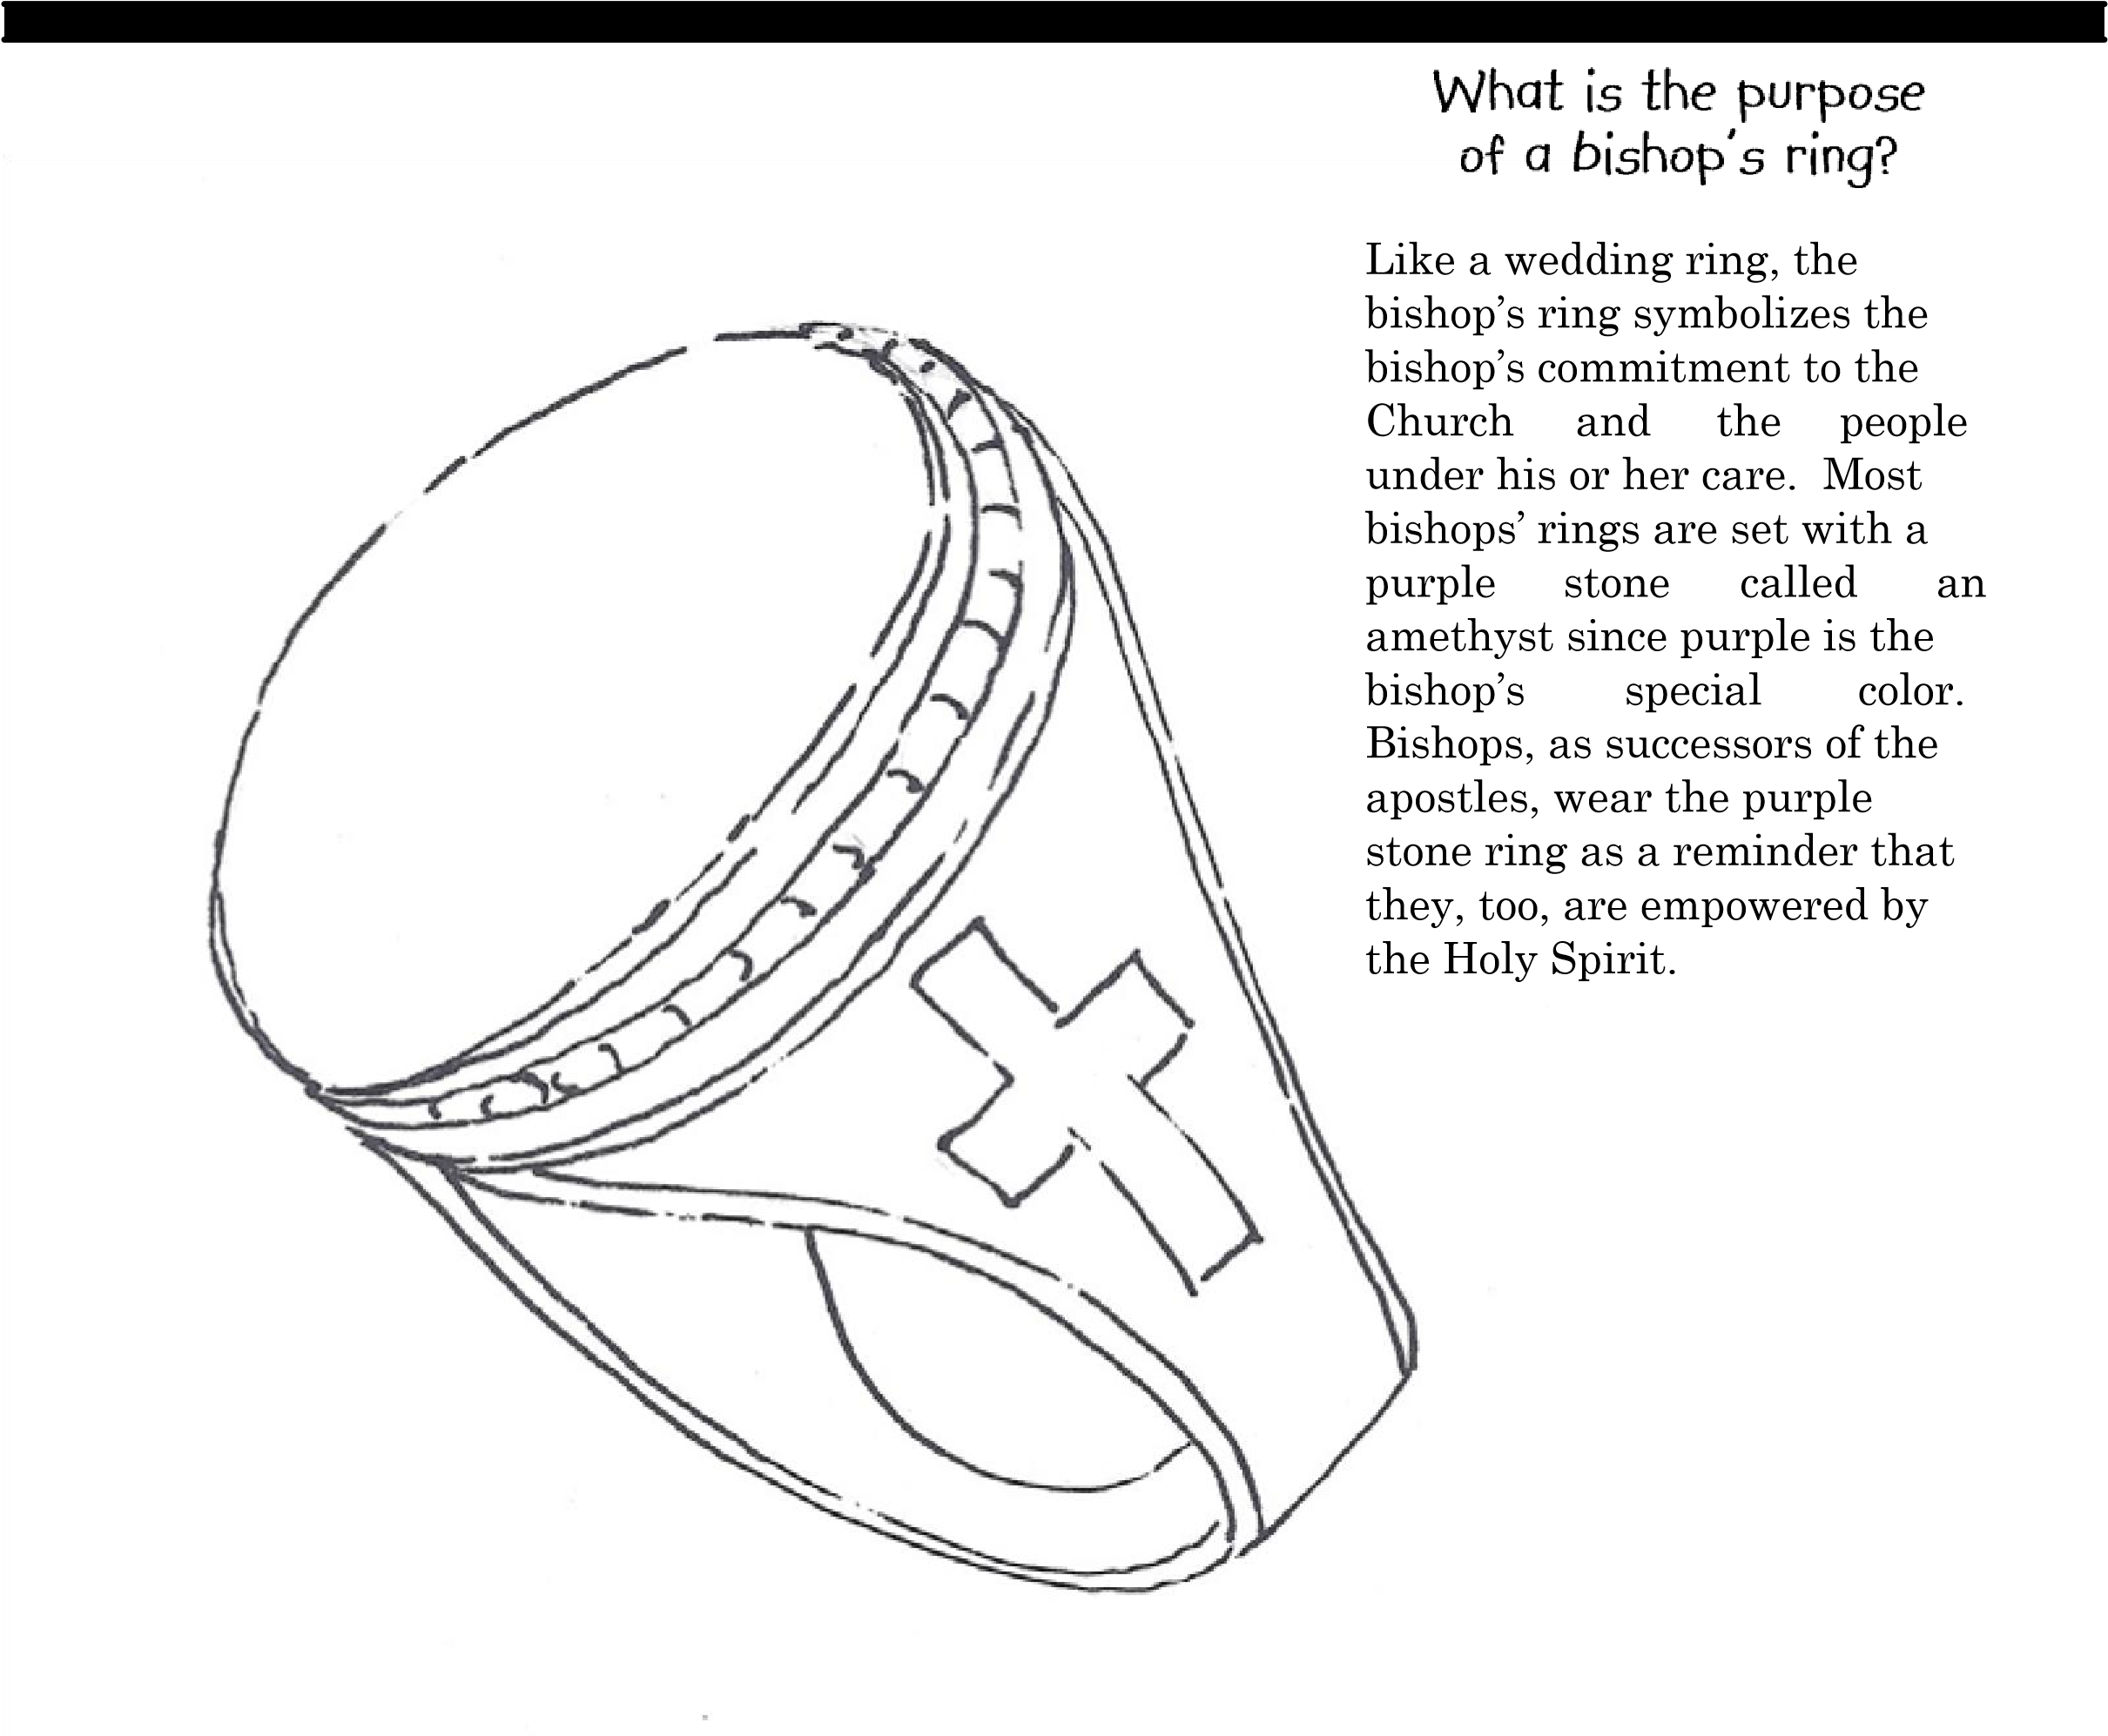
The bishop uses his ring to make a wax seal on ordination documents for clergy. Centuries ago, the seal was used to prove the authenticity of a letter from the bishop. Historically, when a bishop died, the ring was smashed into bits so that no one could communicate in the bishop’s name.

the | seat or throne of a bishop in the church
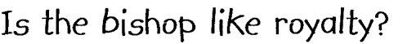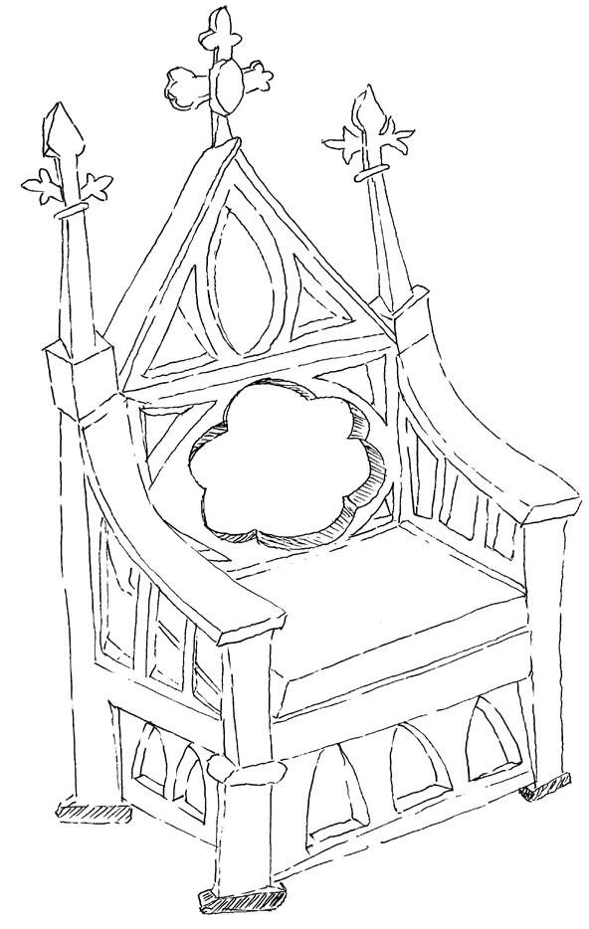
Well, not exactly… but, in some churches a special chair or “throne” is reserved for the bishop to sit in. The formal name for the “throne” is the cathedra.

For Kids:
Ask if your church has a cathedra.

If so, see if your rector will let you sit in it!

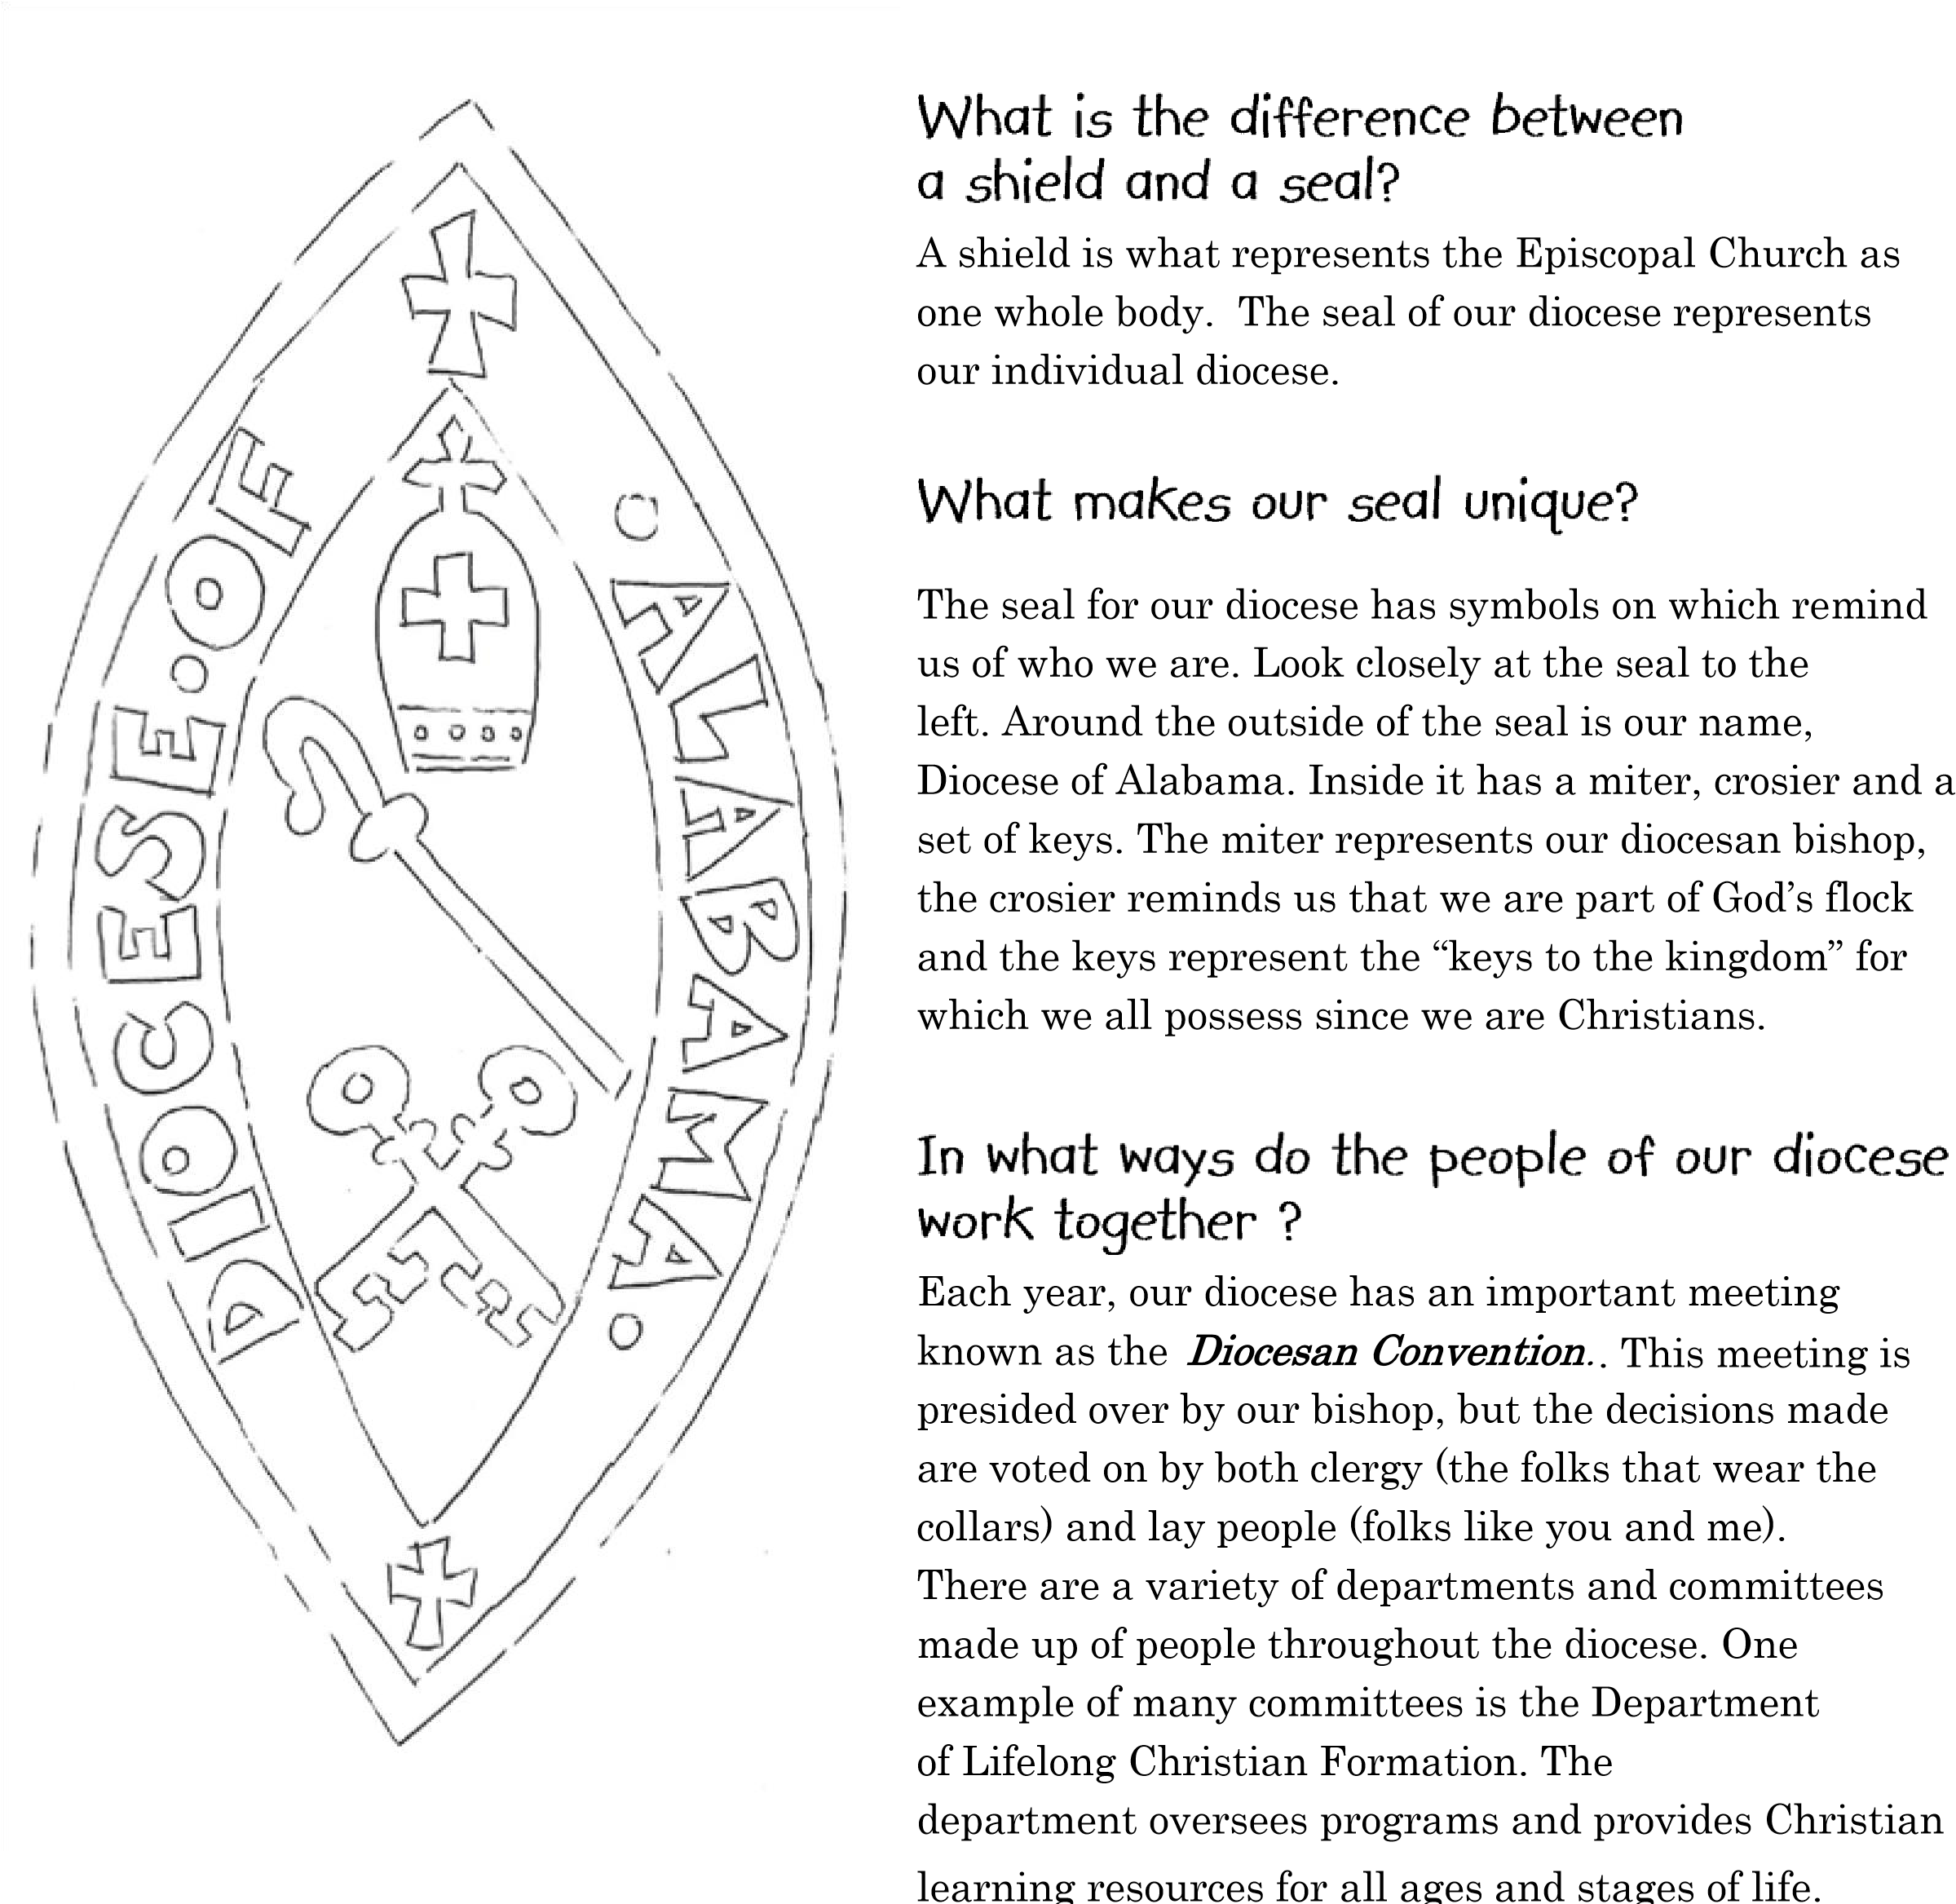

an embossed emblem, figure, symbol,

word

, letter, etc., used as evidence of
authenticity.

For Kids: Follow the maze to help the bishop find the way from Carpenter House to your church!

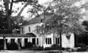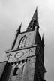

The Carpenter House is where the

bishop works when
they

are
not
visiting

a

church. It is located in downtown

Birmingham.

START

END

12

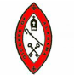
The Department of Lifelong Christian Formation

Updated and edited by department members in 2021 with
Kathy Graham, Diocesan Lifelong Christian Formation Liaison

This booklet was originally produced and edited by the
Department of Christian Formation in 2011.
Editor: Sarah Sartain
Original artwork: Holly Ellis
Original curriculum and design: Madeline Mullins & Holly Ellis

Visit our website: www.dioalaministries.org

