Years of Grace
A History of Grace Episcopal Church, Anniston Alabama
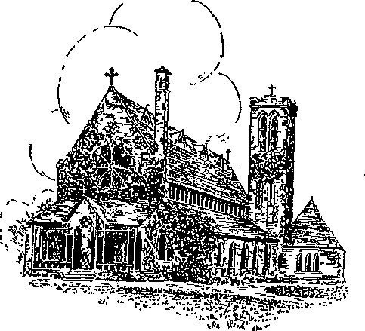

to
"A Poem In Cedar and Stone"

TABLE OF CONTENTS
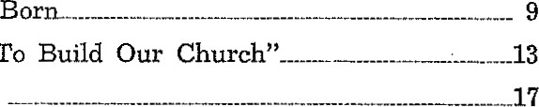
I. A Parish Is
11.
'It
Is
Time
To
'
111. Consecration
- Story of the Institutes---„________--21
- Men, Women and Missions-.-
VI.
Woman's
Work
V
Il.
"Little
Hearts
Vill.
War
and
Chart of Gifts--„-

LIST OF ILLUSTRATIONS
Grace Church before 1886—-
Interior of Church on Day of Consecration--__-16
Early Drawing of the Rectory________ _ _
Noble Institute for BoysNoble Institute for
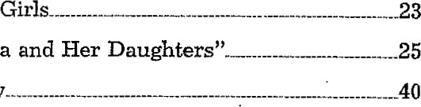
Scene from "Alabama and Her Daughters"- _
Grace Church Today...

FOREWORD
Miss Louisa Nonnenmacher had prepared the History of Grace Church before I became rector, but due to war conditions publication of it was impossible. In 1947 1 asked Mrs. Lentz to rewrite Miss Nonnenmacher's story in brief, popular form for publication in connection with the Anniversary Celebration, May 19,- 1948. Much care was used in summarizing paragraphs and pages and deletion of lists of names, even including those who knew the old times and contributed so much help in gathering the materials. A copy of the original work is filed with the Parish Registers and Vestry papers in the locked, fireproof file in the church office, where it may be studied. At the request of Mrs. Lentz I ivrote the last chapter. Objections arose to the mentiorr of rats, the plague which the city recognized when it undertook its program of rat eradication. My argument is that one of the rats bit me on the hand at the Rectory. Another attacked me on the back porch. The memory of those bold creatures is too vivid to forget so easily.
Another objection arose at the mention of the legend of the barroom which furnished funds for church construction. This story was told me by several of the former members of the Parish and is too colorful to omit, even if its truthfulness cannot be substantiated.
Whatever flaws appear in this vivid little story of Grace Church, "the poem in cedar and stone," we are indebted to these two communicants, Miss Nonnenmacher and Mrs. Lentz, for their labors,

Grace Church Rectory Wm. S. Stoney, Rector
May, 1948

YEARS OF GRACE
1
A Parish Is Born
The Nobles and the Tylers planned carefully and they planned well.
After the War Between the States General Daniel Tyler and his two sons, inspired with great faith in Southern potentialities, came down from the North to establish an industry. They chose a site for their blast furnace in a pleasant Alabama valley, where red clay banks evidenced rich deposits of the iron ore which they needed. They were joined in their project by Samuel Noble and two of his brothers. The Nobles, an English family who had settled in Rome, Georgia, some twenty years before, were seeking new enterprises at the time.
The two founding families brought many laborers from the far away North and even from England to work for their closed corporation, the Woodstock Iron. Company. Around the industry and its workers, the owners laid out and built up a model community with every convenience to satisfy the needs of the inhabitants—a post office, a flour mill, a pharmacy, a commissary and a boarding house-hotel.
This, briefly, was the picture of Anniston in the summer of 1874—a year-old infant already showing signs of progressiveness and idealism—when the Reverend J. F. Smith ca_me up from his Talladega home to conduct the town's first religious service. The congregation gathered on the long front porch of the Woodstock Hotel at Tenth and Noble Streets to hear Mr. Smith. Annistonians then numbered about a thousand. Every person was connected in some way with the Woodstock Iron Company, and almost every person was an Episcopalian.
Even without benefit of a regular parish organization this congregation gathered together whenever the Reverend Mr. Smith could come. Sometimes church services were held at the hotel, sometimes in private homes, sometimes in a vacant store, and sometimes even in the Selma, Rome and Dalton Railroad Station built right across Tenth Street just west of the present Moore Avenue.
This informal arrangement continued for six years. In 1880 the boarding house at Tenth and Noble, which was operated by Mrs. John Tonkin, a cousin of the Nobles, was converted into a chapel. This was an oddly shaped brick building with two long intersecting arms, one running parallel to Noble Street, the other parallel to Tenth. At the time, this chapel was, of course, the only religious structure in Anniston.
Possessed now of a regular meeting place the congregation was able to release the faithful Mr. Smith of Talladega. 'I^{l}hey acquired a rector of their own in the person of the Reverend Frederick Dorset, a close friend of the Nobles. Mr. Dorset brought his family from Rome, Georgia, and lived in a boarding house on Noble Street just north of the chapel. He was shortly followed by a young deacon, Dr. Daniel Hoke of Jacksonville, Alabama, who remained until February, 1881.
The ell-shaped chapel served a dual purpose. On week days it was a school house—on Sundays and special occasions, a church. When Kate Quintard Noble, daughter of the townbuilder Samuel Noble, was married at high noon to E. E. G. Roberts, the school children were given a holiday in order that the wedding ceremony might be performed there. It seems that it was also necessary for the rector to serve a dual purpose—Dr. Hoke was school principal in addition to being minister.
Seven years after the first service was held on the boarding house porch the parish was formally organized. By this time the Reverend Wallace Carnahan had come to Anniston from San Antonio, Texas, taking up his duties February 17, 1881. Mrs. A. L. Tyler, the ' 'Annie" for whom Anniston was named, christened the new parish '(Grace Church," and the canonized articles of association were signed on Easter Monday, April 8, 1881, by the following: R. P. Huger, Alfred L. Tyler, Geo. Noble, S. N. Noble, G. S. Klein, Wm. H. Jeffers, Mrs. Wm. H. Jeffers, Miss Kate Noble, Miss Fanny Fleet,
Miss E. C. Tyler, Mrs. A. L. Tyler, Mrs. Susan T. McMillian,
T. H. Hopkins, J. H. Clabaugh, F. M. Hight, B. F. wyly, Jr., W. A .McMillian, T. D. Parsons. Mrs. Jeffers and Miss Fleet, evidently interested in . becoming members of the first and only church in Anniston, signed the articles even though they were Baptists. The articles were attested by William H. Jef- fers, secretary, and Wallace Carnahan, chairman.
10
After they signed the articles of association the congregation elected the following Vestry: Dr. R. P. Huger, Senior Warden, Stephen N. Noble, Junior Warden, George Noble, T. H. Hopkins, J. H. Clabaugh, W. H. Steiger, T. D. Parsons, Robert Chappell, F. M. Hight, G. S. Klein.
F. M. Hight resigned immediately without serving. Dr. Jesse Zane Wikle, who was elected in his place, established a parish record by remaining on the Vestry almost continuously for nearly fifty-nine years—until January 1940, . when the canons of the church were changed so that a vestryman could not succeed himself. Dr. Wikle had been brought to Anniston by the Tylers and the Nobles to act as company pharmacist and run the company drug store. store was maintained in a little building- next door to the present location of Wikle's Drug Company. Dr. Wikle was elected mayor of Anniston in 1909, a post which he held off and on for fifteen years, and state senator in 1931. He died in July, 1940, bequeating $1,000 to Grace Church, the interest on this sum to be used for charity. He left a similar bequest to the Church of St. Michael and All Angels.
In 1881, the convention of the Diocese of Alabama met at Huntsville and admitted Grace Church into the union, thus completing the formation of the Parish.

GRACECHURCHBEFORE1886.AtextremerightarethefoundationsforNobleInstituteforG .

YEARS OF GRACE
11
"It Is Time To Build Our Church"
Characteristically, it was Samuel Noble who made the decision to begin the construction of Grace Church.
The Noble and Tyler families presented an interesting study in harmonious contrast. General Tyler, a West Point graduate, had served as an officer in the Federal Army during the War Between the States. In the Woodstock Iron Company he acted as adviser and consultant. His was the mind that conceived the overall plans for the company arid the town. He and his two sons were reserved and thoughtful, moving with care and deliberation.
The Nobles, on the other hand, were aggressive and active. They assumed leadership quickly and easily. Samuel Noble was especially apt in his attention to detail and his ability to carry out plans. The combined attributes of the two families built the Woodstock Iron Company into a remarkable and successful venture, and laid the foundations for the prosperous city of Anniston. Now this same unusual combination of qualities was brought to bear upon the matter of erecting a church.
It was during a visit of General Tyler in Samuel Noble's home early in 1882 that the subject was first broached. ' 'General," said Samuel Noble, "1 think it is time to build our church, and I want it to be of stone like the English churches. General Tyler's irnmediate reply was, ' 'I'll do my part." At once the Woodstock Iron Company began construction of Grace Church, using the buff sandstone from a nearby quarry.
Remembering the traditional English village, where the little church was always close by the entrance to the manor house and grounds, General Tyler selected a spot near the gates of the driveways of both the Tyler and Noble estates. The chosen lot was at the corner of Leighton Avenue and Tenth Street. The Tyler house overlooked the property from a hill on the opposite corner. The Noble house was several blocks away, at Thirteenth and Woodstock Avenue, but a tree-lined driveway wound down from the house and ended in a gate at Eleventh and Leighton.
General Tyler supplied plans for the church. During his cadet days at West Point, he had been impressed with a little memorial church in nearby Highland Falls, New York. He commissioned George Upjohn, a famous architect of the time, to draw plans for Grace Church adapted from the New York church he had so admired in his youth. Originally the plans called for a much lower roof and ceiling, with windows at floor level. With the steep gabled roof, the low-to-the-ground effect would have been similar to that found in some of the old English church buildings. Taking into consideration the differences in climate, Charles Milton Noble, Sr., Woodstock Iron Company superintendent, who was in charge of the building, prevailed upon the building committee to permit alteration of the plans, raising the windows and the roof several feet.
It was Samuel Noble's inspiration to carry out in the whole of the interior the cedar, stone and brass architectural theme of Solomon's Temple as described in the First Book of Kings chapter 5, 6 and 7. The knotty cedar which forms the greatest portion of the interior was brought from Tennessee, and for many years its pungent scent pervaded the church.
The stone exterior was given great consideration by Samuel Noble. His dream was to have it worked by a craftsman of the ' 'old school." Back in Cornwall, the Noble family home in England, there lived such a master craftsman—Simon Jewell. Jewell had learned stonemasonry during many years of the arduous apprentice system, which was gradually dying out under the influence of the industrial revolution. To carry out his ideal of beauty for Grace Church Noble sent to Cornwall and brought Jewell to this country. It was said that stones were to this expert mason like precious gems. He held each individually in his hands and planned with care the exact chiseling which would bring out the proper lights and shadows inherent in its shape. His craftsmanship is immortalized not only in Grace Church but in other Anniston buildings such as the Parker Memorial Baptist Church, the First Christian Church and St. Michael's. Wherever Simon Jewell worked, the stones of the buildings are characterized by deep vermiculations, or tool marks, bringing out effective light and shadow contrasts which change constantly with the variations in sunlight throughout the days and seasons.
General Tyler never lived to see the completion of the
14
church in whose construction he had played such a vital part. The foundations had been laid and the stone from a nearby quarry brought to the site early in 1883, when news came to Anniston of the general's death in New York City. His body was brought back to Anniston on a special train furnished by President Roberts of the Pennsylvania Railroad—for Daniel Tyler had been closely associated with the railroad industry in Pennsylvania through his former iron business. As a tribute to the loving interest he had shown in the new church the Episcopal congregation held his funeral within its foundation enclosure.
Every week, Robert H. Hampson, Woodstock Iron Company office boy, drove paymaster H. V. Marshall in a carriage to the site of the building to pay off the laborers. Funds used in erecting the building came from the proceeds of a sort of tavern maintained on Tenth and Noble by the Woodstock Iron Company. The story goes that when company directors found that their laborers were patronizing open saloons on the edge of town near Oxford, they installed a barroom in the regular commissary building which could be properly supervised. On the ale sold here they placed a tax which went toward financing the church. After a few years a prohibition law was passed, cutting off the sale of ale and, hence the source of revenue The Iron Company was compelled to abandon building the porch called for in the Upjohn plans and to complete the church with a temporary makeshift structure in front.*
Ever since, the church building which the Woodstock Iron Company completed in 1885 has been used by architectual text books as a model of perfect proportion and pure Gothic style. Literary tribute was paid to its beauty by James Ryder Randall, author of "Maryland, My Maryland," who for a short time was editor of the Daily Hot Blast. He is said to have called the church "a poem in cedar and stone.'
* This "temporary" porch was still standing 63 years later when the Reverend W. S. Stoney, rector, appointed a committee to investigate plans for replacing it with a suitable structure.

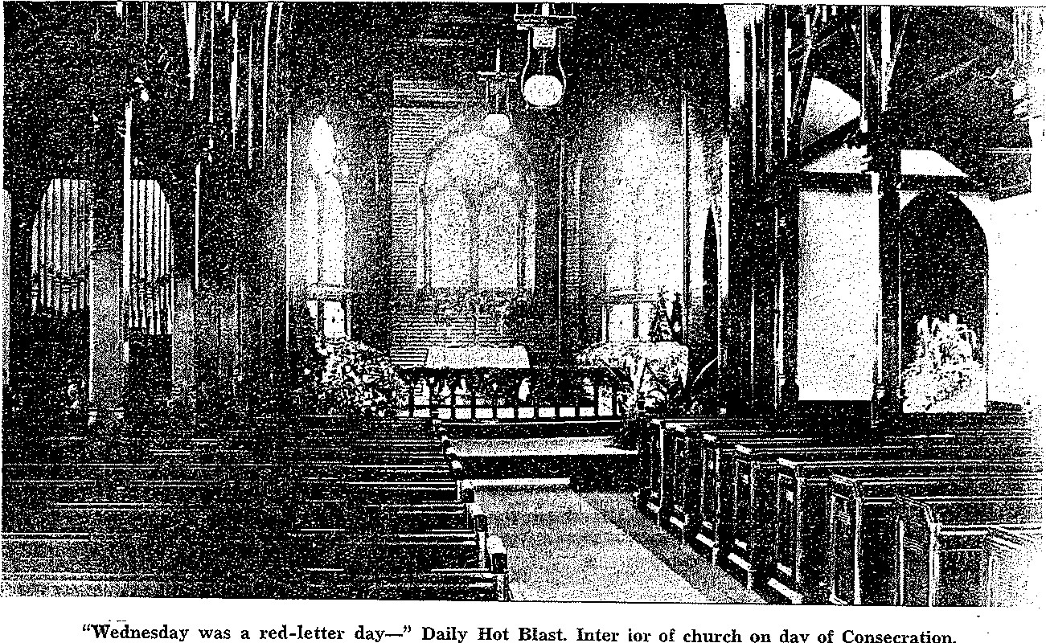
"Wednesday
was
a
red-letter
day—"
Daily
Ho
丶
mast.
Inter
ior
0
、
church
on
day
consec
、
:ation.

YEARS OF GRACE
111
Consecration
At midnight Christmas Eve, 1885, Anniston Episcopalians gathered for their first service in the new church.
Several months . later the church was consecrated when the 55th annual convention of the Diocese of Alabama was held for the first time in the parish. The actual consecration took place at the opening service of the meeting, May 19, 1886. At that time the deed of gift, which had been presented to the Diocese of Alabama by the Woodstock Iron Company, September, 1883, was handed to the Right Reverend Richard Hooker Wilmer, Bishop of Alabama.
The Anniston Daily Hot Blast of May 22, 1886, carried the following write-up of the consecration service:
Wednesday was a red letter day, not only to the ones interested in this church, but to everyone in Anniston, for on that day the new Episcopal church was consecrated. The church was filled not only with people of Anniston but from all over the state council of the Episcopal church in Alabama held their meeting at this •church at this time.
The floral decorations had to be seen to be fully appreciated. The banks of. flowers under the three chancel windows were rare hot house flowers. The chancel rail was wreathed with ivy while palms and ferns hid from view the lectern and prayer desk, and the font was beautifully decorated.
The font which was given by Mr. E. L. Tyler and Miss Tyler contained a pyramid of valley lilies, roses, daisies and ferns, while a garland of white flowers reached to the pedestal, meeting the vines which wreathed the base. The dressing of the church was done by Miss Addie Noble, Miss Tyler, Miss Grace Noble, and Mrs. Dr. Huger with flowers from their conservatories.
The spotless linen on the altar was used for the first time. This was presented by Mrs. A. L. Tyler. The organ, finished in cedar to correspond with the finishings of the church, was donated by Mr. John Ward Noble and was built by Pilcher and
Sons of Louisville, Kentucky, whose very name is a guarantee for sweetness of tone and beauty of finish, and was played by Mr. Pilcher in the most skillful manner.
Promptly at 10 0'clock the procession of clergy entered the church from the main entrance, headed by the Right Rev- erend R. H. Wilmer, bishop of Alabama, followed by the Right Reverend C. T. Quintard, bishop of Tennessee, who were followed by Drs. Tucker, Stringfellow, Barnwell, and Stickney. As the procession moved up the aisle they repeated alternately the twenty-fourth isalm. After reaching the chancel, the instruments of donation and endowment were presented by John W. Noble and Alfred L. Tyler as representatives of the Woodstock Iron Company and after the sentence of consecration was read, the deed was placed on the table. The consecration sermon was preached by Dr. Stringfellow of Mont— gomery, and the Holy Communion was administered by Bishop Wilmer to a large number of communicants after confirming a class of thirty-one people,
Lila Noble (Mrs. Richard Proctor) Huger was the first organist. She was the daughter of John Ward Noble and sister of Ermie Noble, for many years organist at the Church of St. Michael and All Angels. Mrs. Huger served in this capacity until the establishment of the Noble Institute for Girls, after which time it was customary to have the music teacher at the school take over the organ and direct the choir.
The Reverend Wallace Carnahan had guided the Parish through a period of great activity. He saw completed not only Grace Church but also the two institutes, Noble Institute for Boys and Noble Institute for Girls. He himself had presented Grace Church with its first altar which was made of California redwood somewhat lighter than the rest of the cedar interior.* In addition to his parish duties he was actively engaged in welfare work among the factory people, carrying his charitable deeds even to the point of depriving himself of personal comforts in order to help destitute families. In his book, "Odd Happenings," he mentions some of this work among factory people. Jul' 12, 1886, the Reverend Mr. Carnahan handed in his resignation, held his last service August 29 of the same
* In 1894 the ladies of the Parish Guild replaced this altar with an altar and retable designed by R. Geissler of New York. The original was then donated to another Episcopal church in Alabama.
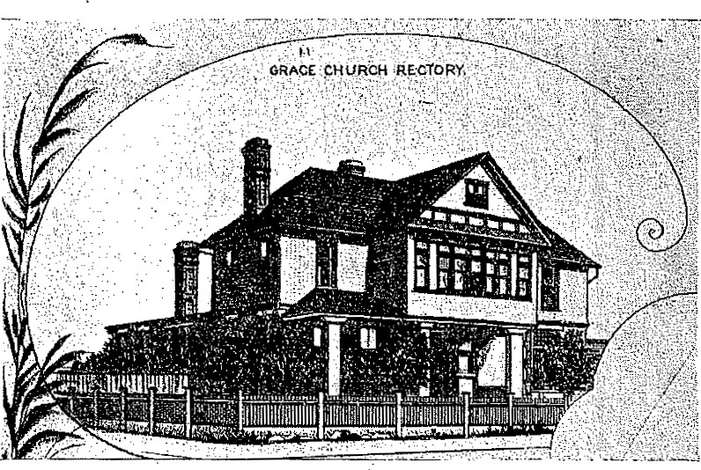
This early drawing of the Rectory appeared in a pamphlet entitled "Souvenir of Anniston, Alabama," published in 1889 by the Anniston City Land Company.
year and left two days later to become rector of a church in Little Rock, Arkansas. Before he left Anniston the young men of the Episcopal, Methodist, Baptist and Presbyterian congregations presented him with a gold headed walking cane to show their affection and respect for him and their appreciation of his service to the community, as well as the church.
Soon after, some time in 1887, Anniston experienced a period of great prosperity. The Reverend Philip Augustus Pitts had succeeded Carnahan as rector, and during the first four years of his stay it was necessary to place chairs in the aisles to accommodate the crowds who thronged to services in Grace Church every Sunday.
No doubt feeling the effects of this boom the congregation began building' the rectory in 1887: It was completed and furnished in 1889 at a cost of approximately $10,500.

NobleInstituteforBoyswasbuiltOfredbrickandnativestone.Thecitytookoveritsoperationafter hadserved
fortenyears achurchschool.Itbumedtothegroundin190andwasneverrebuilt

YEARS OF GRACE
Story of the Institutes
Grace Church had been under construction for two years when Samuel Noble, with typical efficiency and imagination, conceived the idea of the Institutes.
The best possible education, he said, could be Obtained only under the guidance of the Church. Accordingly, on June 25, 1884, he deeded to a board of trustees *certain stocks whose proceeds were to be used for erecting and equipping two separate church schools for girls and boys. Woodstock Iron Company had dlready given the diocese a piece of land just north of Grace Church and a hilly block between Seventeenth and Eighteenth on Leighton Avenue. In 1886 Noble saw another of his many dreams for his town and church come true when Noble Institute for Girls and Noble Institue for Boys were completed on these two lots respectively.
Ten years later the Diocese, finding that operation of the schools was quiet a problem and not wishing to take the responsibility of keeping them run_ning, deeded them in fee simple to Grace Church.
The boys' school was a long story-and-a-half structure, built of native stone and red brick. Square windows, two-by-two, extended on either side of the Romanesque door. At each end was a colonnaded porch with a gabled roof. The building with a wide driveway curving in front of it faced south from the hill top on which it was placed. Small pine and oak saplings grew at sparse intervals over the grounds.
Noble Insitute for Boys was destined to have a very short career as the religious educational center for which it was planned. Nehemiah D. Van Syckle, who later entered the ministry, was the first principal; his vice-principal was Jarnes Jefferson Davis Hall, who became afterw.ard a famous New
This board of trustees was composed of the following men: the
Rt. Rev. Richard H. Wilmer, Bishop of Alabama, Rev. Telfair Hodgson, Vice-Chancellor of the University of the South at Sewanee, Rev. Wallace Carnahan, Rector of Grace, Church, Alfred L. Tyler, John W. Noble, Francis M. Hight and Stephen Edward Noble.
York evangelist. Other principals were R. H. Willis and Jacob Forney of Jacksonville. At one time Will McKe11ar was in charge of the school, and Henry Pitts, son of Dr. Phillip A. Fitts, was one of the teachers. The last principal, the Reverned Joseph Francis John, was also rector of Grace Church. Only ten years after it opened as a church school, the Institute was leased to the city of Anniston and became on August 31, 1896, Boys' High School. The city operated it as a public school until January 31, 1910, when the building burned to the ground. It was never rebuilt, and in 1918 the plot of land on which it had stood was sold.
The girls' school next door to the church, on the other hand, had a quite different history. For its first few years it was operated as a day school. Then in 1889, after Samuel Noble's death, his widow and children erected as a memorial to him a dormitory north of the school building on the corner of Leighton Avenue and Eleventh Street. Episcopal girls came from all over this section of the South to board after that time. The family employed Chisolm and Green, architects, and S. Larned, contractor to build this memorial domitory.
A model of elegance, the dormitory was sumptuously furnished throughout, Downstairs the main reception rooms and halls were covered with velvet carpets, while Brussels carpets were spread over the other floor spaces. In the entrance hall hung an heroic sized oil pai_nting i_n a gold frame depicting Anniston as it appeared from the Noble home in 1882. The Noble family supplied the dining room with best quality silver and appointments. Two boarding students lived in each of the twin-bed rooms upstairs while the principal's family stayed in a suite of rooms which was separated from the rest of the second story. A music room, a study hall, a large library, art gallery and gymnasium occupied the third floor.
Morning prayer began each school day at a quarter to nine. Frequently parents of day students and regular members of the congregation joined in this service which was held in the large, bright auditorium of the school building proper. Music, art and dramatics were taught in addition to regular school curriculum until two-thirty or three o'clock in the afternoon. At six in the evening dormitory girls had their dinner which was followed by a recreation period. Study hall lasted until prayers, just before bed time. No classes were held on special church days such as Ash Wednesday and Good Friday, but, it was emphasized, these were "holy days"—not "holidays."
22

」9881u!110… 日03 一 Rwaoqs D.10} qo

The Noble Institute for Girls became a cultural center for the town. At commencement time, which lasted a full week each year, Annistonians attended en masse recitals and plays. staged at the school. Dr. Wikle took the senior girls on a picnic to Oxford Lake or some other scenic spot close by, On the day of graduation the students marched around the quadrangle singing ''We march, we march to hymn which they were required to memorize in its entirety. One of the last ceremonies of this gala week was the "tree planting" celebration in which books were buried around the dormitory grounds; and trees—or more often ivy shoots— were planted above them. Few if any of the trees survived, but the ivy lived and gradually crept over the walls of the buildings.
Mary Bethune, a cousin of Senator Maximilian Bethune Wellborn, and a close friend of Bishop Wilmer, was its first principal, with Mrs. A. L. Tyler as next in charge. Then came Emma Bristow—from Columbia Institute in Tennessee, where Addie Noble (Mrs. W. L.) McCaa had been one of her pupils. She was followed in the order named by Mrs. Waddell, Nannie Water, Mrs. T. S. Stribling, Eleanor Otey Anderson (18991902) , Matilda Gray and Ethel Moore, joint principals, (19021910), the Rev. James G. Glass (1910-1912), and the Reverend Joseph H. Spearing (1912-1914). Margaret Lea took over in 1914 and for eight years operated the Institute as a co-educational day school.
Sunday, May 20, 1894, the school building burned, and the fire spread to the northern portion of the church. Workers were able to save all the pews and movable furniture in the church. They took the font out, but it was slightly damaged. The most serious casualty was the large window over the altar which was completely ruined. The ladies of the congregation asked Mrs. Alfred Lee Tyler, Sr., who was in New York at the time, to select a new window. Her choice was the stained glass portrayal of Christ among the lilies.
After the fire the school was rebuilt and used as an institution of learning for twenty-eight more years. By this time püblic education and the state college systems were firmly established in Anniston and surrounding territory. It became nnpossible for the Parish to operate the school in competition with these other institutions without an endowment of assistance. The school was closed in the spring of 1922, and the building was converted into a Sunday School and Parish House for the church. In 1914 the dormitory was, changed to a resident hotel named the Noble Arms, and finally sold outright in 1945.
24

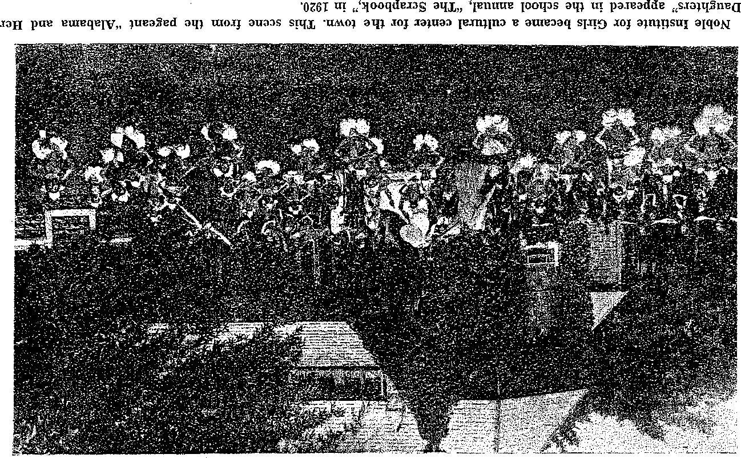

YEARS OF GRACE
Men, Women and Missions
During the time that Dr. Fitts served as rector of Grace
Church, John Ward Noble, Samuel's brother, conceived the . idea of building St. Michael and All Angels as a place of worship for working people west of Noble Street. At a meeting December 6, 1887, the Vestry granted him permission to begin work on the new church,
For quite a while the two churches in their development were intimately allied. St. Michael's first Vestry and a large portion of its membership were drawn from Grace's congregation.
Already Grace Parish's absorbing interest in local mission work had manifested itself. Around the year 1886 Glen Addie Mission had been started in an empty store and St. Luke's Chapel had been built at Eleventh and Pine Avenue. John Noble planned that, after St. Michael's was completed, these mission congregations would attend service there.
St. Luke's had a resident minister, the Reverend C. H. Lock" wood, for at least a year. Mrs. Samuel Noble paid his salary, while her sister, Kate Stoeckel, assisted by Annie Noble, conducted a sewing school at the mission. During the time when there was no resident minister, Thomas Burry was the lay reader in charge. As John Noble had foreseen, this mission was closed as soon as St. Michael and All Angels was completed.
In 1888 John Noble built a little wooden chapel, known as St. Paul's, which he planned as a temporary home for the congregation of Glen Addie Mission until the members could attend St. Michael's. Contrary to plans, St. Paul's did not close when St. Michael's was finished, but was continued for a number of years as a mission and Sunday School. Noble Institute students joined with volunteers from Grace Church to teach and work in the mission. While the Reverend Joseph Francis John, who succeeded Dr. Fitts in 1894, was rector, the Baptists bought St. Paul's and changed its narne to Glen Addie Baptist Church.
Dr. Pitts remained as rector of Grace Church for nearly
eight years, leaving Anniston in April, 1894. His successor, the Reverend Joseph Francis John, came to Anniston from Uniontown, Alabama, September I, 1894, and served the parish until December 1, 1900. He was followed by the Reverend Francis Langdon Coyle, who assumed the rectorship December 15, 1900, and remained until February I, 1902. The Reverend James Gamwell Glass came to Anniston from Summer„ Ville, South Carolina, in the summer of 1902 and remained for ten years. During this time he also served as secretary of the Diocese of Alabama.
The third in a long procession of missions was established on Kaplan Row while the Reverend J. G. Glass was rectoi•. Benjamin Carpenter of Chicago, president of the Anniston Cordage Company, gave the mission the use of a six-room cottage. One of the most unusual projects carried out here was the maintenance of a bath house. Every Saturday afternoon a group of Episcopal women visited the people of this district, brought in the slum children, bathed them and supphed them with clothing. Kaplan Row Mission continued for about two years.
About the end of 1912 the Reverend Mr. Glass left Anniston for Florida. The next rector was the Reverend John Durham Wing, later Bishop of Southern Florida, who came to Anniston from Atlanta in November, 1913. He remained until June 30, 1915, when he left to go to Christ Church, Savannah. He was succeeded, about a year later, by the Reverend Carlton Barnwell, of Westminister, Maryland, who served from the summer of 1916 through the difficult war years. Camp McClellan had just been constructed and there were at one ti_me 40,000 troops stationed there. The Reverend Mr. Barnwell
specialized in working among these soldiers. He left Anniston October 10, 1920, to go to Grace Church, Lynchburg, Virginia.
A long pei'iod of intense concentration on the underprivileged classes in the community was ushered in when the Reverend James Moss Stoney assumed his duties as rector on June 12, 1921. During the early years of his ministry, his wife, Mary Clifton Roberts Stoney, undertook the herculean task of reopening St. Michael's Clinic. Previously operated as a dispensary by the women of St. Michael's, the clinic had been compelled to close for lack of funds, The new organization was
operated under the sponsorship of Grace and St. Mitchael's, with a board composed of an equal number of persons from each church. Mrs. Stoney served as first president of the clinic and worked continuously in it until her death in 1924.
In honor of the two churches sponsoring the clinic the first baby, a boy, born there was named Michael and the second baby, a girl, was named Grace. This clinic cared for thousands of charity patients during -its period of operation. When Garner Memorial Hospital was opened in 1920, Anniston physicians decided that all charity patients must be taken care of in the charity ward of the new hospital, and consequently the clinic was closed. In addition to serving as a haven for underprivileged hospital cases the clinic was also the inspiration for a great deal of related welfare work, Perhaps the most lasting effect of St. Michael's Clinic on this city has been the organi zation of the Anniston Community Chest of which it was the acknowledeged forerunner.
Another example of the Reverend Mr. Stoney's interest in the underprivileged of the city and county was the establishment of the Chapel of the Resurrection in 1922. Mr. and Mrs. Dalton Whitford contributed a piece of land on the Gadsden Highway, and on this property a simple wooden church building was erected. Sunday School and church services were held every Sunday for the people of the vicinity. Pioneering in the establish_ment of this chapel were Mrs. Elbert Decatur Willett and Mrs. George Reid, who visited families all through the surrounding countyside, and saw to it that poverty stricken children were fed and clothed.
In January, 1924, Mrs. Chives M. Woodruff became director of the chapel. She found it in a precarious state, on the verge of failure because of a lack of volunteers. She went to work immediately with Mrs. Louis Henry Klein, Sr., Mrs. Reid and Mrs. Willett. They canvassed the surrounding countryside for chapel pupils and built up a sizable congregation. Mrs. Reid gave the organ, which she herself played for years, and supervised the altar work, seeing that flowers were always provided and that hangings were properly cared for.
Under Mrs. Woodruffs leadership the work assumed very large proportions. On May 22, 1927, a chapel bus made its first trip, with Mrs. Reid and Mrs. Willett riding in it to shepherd the children to and from Sunday School. Attendance increased so rapidly that by cold weather it was not possible to take care of all the children. It was then that the rector decided to start a new mission,—the first offspring of the Chapel of the Resurrection—the Chapel of the Redeemer, which was established in Glen Addie.
After the death of Dalton Whitford his widow served as caretaker of the chapel of the Resurrection. In December, 1931, some time after Mrs. Whitford had relinquished these duties and left town, *the Chapel was moved bodily to Leatherwood. Most of its congregation lived in this community. The building was improved and the membership grew to about 100 persons, When Fort McClellan began to mushroom with the threat of war in 1941, many of the Leatherwood families were moved away so that the army could add Pelham Range to the reservation. The opening of the rifle range sounded the death knell of the Chapel of the Resurrection.
Gradually the Reverend Mr. Stoney's talent for missionary work brought more and more outlying congregations into his charge, In addition to Grace Church and the Anniston mis- sions he also conducted at one and the same time St. Luke's in Jacksonville; St, Peter's in Talladega, the church in Piedmont, and a mission at Alpine. This tremendous field of endeavor brought him a succession of assistants. First came Captain Ralph Hudleston Channon of the Church Army who served from 1936 to 1941. He left to take charge of the church at Troy and the mission at Union Springs, preparatory to being ordained a deacon and later a priest. Marshall Seifert arrived in 1936 to serve along with Captain Channon while preparing himself for the ministry. After his ordination in. June, 1941, Robert Clingman, son of the Right Reverend Charles Clingman, Bishop of Kentucky, came to take charge df St. Peter's and the Alpine Mission. After he left Captain Carlton Potter Greene, also of the Church Army, and William Hosking, a Sewanee divinity student, assisted the rector.
Forty years after the establishment of the first mission in Glen Addie Grace Church, under the leadership of its rector, once again returned to the neighborhood and opened the Chapel of the Redeemer, early in 1928. This new chapel took care of
Mrs. Whitford later became a deaconess and served as matron at the Church Home for Orphans at Mobile.
the overflow of children who had been riding the bus to Leatherwood to attend the Chapel of the Resurrection, The first home of this new mission congregation was a little cottage at Fourth and Mulberry Avenue. Later the Anniston City Land Company donated a lot at Seventh and Mulberry, and the congregation moved into a wooden chapel built there.
Until her health failed Harriet Tabb served as director of this mission. After she was compelled to give it up the work continued under the direction of Captain R. H. Channon. When Captain Channon left, Captain Carlton Greene took charge. Sunday School and church services were both conducted at the Chapel of the Redeemer, and on week days the young people of the Glen Addie Community gathered there for play and study. In 1940 the houses of most of the Redeemer members were torn down to make way for Glen Addie Homes, a federal housing project.' This scattered the congregation so widely that only a fraction remaihed in the neighborhood. Outbreak of World War Il added the finishing toüch to the dissolution of the Chapel. A committee appointed by the Vestry. studied the situation carefully and recommended that the mis-. sion be closed. Acting on this recommendation, the Vestry terminated the mission project and sold the chapel property in May, 1945.
For a number of years William R. Bride had been working among the people of Mechanicsville. Every Sunday he brought children from the neighborhood to Grace Church and the Chapel of the Redeemer. In 1935 William H. Deyo lent a store building in which a mission was established for this community, the Chapel of the Epiphany. Later the congregation moved into a cottage, also supplied by Mr. Deyo. In 1936 Mr. Brice died and chapel work was carried on by the rector's assistants, Captain Channon, Marshall Seifert and Captain Greene. Mrs. William R. Brice worked in the chapel with her son, Forney, who served until he entered the army in the spring of 1941. The Epiphany mission was closed in 1941, during the first winter of the 'war.
By this time the third in a series of Sunday School busses was ailing and old. No ration tickets could be obtained for tires and gasoline as it was not registered and had no owner or license. The body was an old abandoned school bus body, the chassis had been salvaged from a junk yard, and the motor had been worked over so many times that the numbers had been obliterated. Its last trip was made with about three of the tires stuffed with sawdust as they would not hold air any longer. The next week a cruel cold spell froze the water in the motor and cracked the block. The bus was last seen being dragged off to be melted down into shells for the army and navy.
Wherever a community had been touched by chapel work, its residents were profoundly affected. The preaching missions, cottage prayer meetings, annual picnics, Easter egg hunts, Christmas trees, pageants, canning parties in the Stoney's home, Woman's Auxiliary and Young People's Service League meetings not only enriched the spiritual lives of participants but raised their economic conditions and improved their living standards.
After twenty-one years of service as rector of Grace Church, the Reverend James M. Stoney was elected Bishop of New Mexico, February 5, 1942. With his consecration April 16 at St. Michael and All Angels, an era ended for the Parish. War had started and the army was pouring thousands of men into Fort McClellan. Uniformed soldiers appeared in Grace's red-cushioned pews every Sunday, and men with khaki collars showing beneath black and white vestments sang in the choir. A new minister was on his way to Anniston to lead the congregation. Out of these turbulent changes a different kind of parish began to develop.
YEARS OF GRACE
''Woman's Work Is Never Done"
As soon as there was furniture to polish, brass to shine, and linen to launder for their church, the women of the Parish banded together, rolled up their sleeves and went to work at the never-ending job of ' 'churchkeeping.'
The Grace Church Parish Guild, the first formal organization for women, was founded in 1886—the year of consecration. This group of women did charity work in addition to the choir and altar duties. They sponsored all parish social functions and decorated the church for special services such as Christmas and Easter. They sewed for St, Michael's Clinic after it was reopened and sent clothing to the Church Home at Mobile and to the Indian Mission. From the funds raised through contributions and through barbecues and serving meals to civic clubs, the Parish Guild for many years kept a steady stream of gifts pouring into the church—the altar and retable, the altar window, a vari-colored supply of altar hang„ jngs, music, choir vestments and metal wall vases for special decorations. They had the church interior redecorated and repaired and at one time recarpeted the floor and bought new cushions for all the pews. They also took charge of the church grounds, setting out shrubs and supervising all planting.
In addition to this Parish Guild, the Woman's Auxiliary was first organized while the Reverend James G. Glass (19021912) was rector. The Auxiliary emphasized service in church, parish, diocese, nation and world and sponsored special study and lecture courses during Lent, St, Michael's had no such organization at that time and sent two representatives to the meetings of the Grace Church group.
The Reverend John Durham Wing (1913-1915) organized a local branch of the national Daughters of the King. He selected as charter members five wornen whom he considered particularly faithful in attending church and Holy Communion services. They were the rector's aides. They took vows of prayer and service, promising to perform any duties the rector asked, regardless of conflicting engagements. They had charge of the altar and the communion vessels and welccnned and visited newcomers. The minister directed them in charity work. During the depression of the 1930's members often left baskets secretly on the doorsteps of destitute parishioners. They never reached a membership of more than twelve women during their fifteen or twenty years of service; nevertheless they presented to the church the large brass alms receiving basin, contributed funds for local work and with their dues supported the national program,
The reopening of St. Michael's Clinic in 1922 was the inspiration for the founding of the Social Service Guild. Early members nursed at the clinic, provided nightgowns and layettes, and did regular follow-up work for discharged patients. A crippled children's clinic originated by this group later was adopted by civic clubs and became a permanent part of the town's social work program.
Rapidly increasing its scope of activity, the Social Service Guild expanded to include mission work and to furnish free lunches for undernourished public school children and milk for tuberculor children. In addition the members assumed many parish responsibilities, supervising the Junior Lenten Choir and the Sunday School and assisting the Parish Guild in altar and choir work, To raise money for their various pro. jects, these women sponsored pet shows and exhibits of silver, glassware and antiques.
On November 18, 1927, business women and those who could not attend regular Guild or Auxiliary meetings united to form a Businesswomen's Guild. The objectives of this organization were to extend church work, to support the Sunday School, to look after newcomers, and to help underprivileged boys and girls become useful citizens. Members served barbecues, held cake and rummage sales and operated sandwich and hot dog stands at county fairs to raise funds for their work. Adopting the chapels, they provided Christmas gifts for the children, dyed Easter eggs, financed annual picnics and helped pay for repairs to lüission buildings. Several times during their nine years of existence, they sent a boy or a girl to Young People's Service League summer camp. In 1936 their ranks were so depleted through removals, illness and death that the few remaining members, unable to carry on the work alone, decided to disband.
In 1934 the members of the various guilds took the first step toward providing a unified program for all parish women. They realized that their program was deficient in two important respects: too many women communicants were not included in church activities; and the parent organization, the Woman's Auxiliary, was limping along with a handful Of supporters, barely able to meet its financial commitments. Accordingly all the groups except the Daughters of the King drew together into units of the Woman's Auxiliary.
Theoretically, members were supposed to meet both in units, or guilds, and in a general auxiliary. Actually, the original Grace Church Parish Guild, now called Unit Numbei One, or the Senior Guild, and the Social Service Guild, renamed the Junior Guild, or Unit Number Two, continued to go their separate ways. Maintaining only a haphazard unity in the Woman's Auxiliary, they elected different sets of officers and carried on separate fields of endeavor. The Businesswomen's Guild existed for only two years as Unit Number Three.
Finally in 1943 true union was attained. All members of both guilds agreed to inaugurate the plan nationally recommended for auxiliaries. Four chapters were formed and named for four Bishops—Stoney, Carpenter, MacDowell and Cobbs, There were general officers for the Auxiliary as a whole, as well as officers for each separate chapter. Chapter membership was determined by lot in a ceremony at the beginning of the year when every leader drew her quota of names from a hat. Parish duties were divided into four projects, and each chapter took a turn at each project for three months of the year. Every woman in the Parish was considered a member of the Woman's Auxi_liary. Early in 1944 a fifth chapter was added consisting of women who could not attend afternoon meetings. This Bishop Wilmer Chapter was actually a reactivation of the old Businesswomen's Guild.
The long war years gradually took their toll of Auxiliary work. The Young Women's Christian Association rented the Parish House for their United Service Organization so there was no longer a hub of activity around which the Auxiliary could plan. Local agencies were drawing off volunteers from all women's groups. There was a minimum of time and space for Auxiliary functions. By 1946 when the war pressure was finally relaxed, Episcopal women were so exhausted from years of USO and Red Cross work that there was little enthusiasm among the remaining faithful few who still attended to altar and choir work. Both general and chapter meetings grew smaller. In the fall of the year the nominating committee sadly reported that no woman was willing to shoulder the leadership of the organization.
Once more the women of the Parish reorganized, This time they turned their chapters into functional groups. Instead of rotating, chapter duties remained the same throughout the year. Every •woman communicant of the church was asked to express her chapter preference. The Churchkeepers (Bishop MacDowell Chapter) took chargé of the choir and the church building and grounds. The Hostesses (Bishop Carpenter Chapter) served all luncheons, called on invalids and welcomed newcomers. The Parish Planners (Bishop Stoney Chaper) took care of the Parish House, did social service work, and raised money for Auxiliary projects. Women who could not attend any of the meetings were placed in the Firesiders (Bishop Cobbs Chapter) and were asked to serve whenever possible in their homes. The Altar Guild was composed of all women who wished to belong, regardless of chapter affiliation. The Businesswomen's Chapter remained unaltered, but members seriously studied ways of becoming better integrated with the group as a whole. Prospects for a more even division of labor enabled the group to secure a president, and the work again went forward.
With the Parish House back in its hands and a rapidly growing membership the Woman's Auxiliary began to thrive again. In all departments of their endless work the women looked ahead with renewed inspiration.
YEARS OF GRACE
"Little Hearts May Love Thee Well"
It took forty years for the Parish to begin developing a wellrounded program for its young people. From the time it was organized in 1881 until 1921 when it sponsored a Boy Scout troop Grace Church offered nothing to its children except Sunday School.
In 1874, even before the Parish was organized, Sunday School classes were held in the second story of the building occupied by Wikle's Drug Store. The store was next door to the Noble Street boarding house on whose long porch the Reverend J. F. Smith conducted Anniston's first church service. In 1880 the Sunday School followed the church to the ell-shaped chapel across the street, and in 1886 it moved permanently into Noble Institute for Girls.
Augustine Henry Shepperd, in the position of Sunday School superintendent, established a parish record. He served in that capacity long enough to see several generations pass through the school. Miss Annie Noble taught Sunday School for fortythYee years, longer than any other woman in the history of the church.
Children of the early Sunday School were taught to work for their church. The Bishop's Chair was given by the ' 'Ten Minute Society," a class of little girls. Members devoted ten minutes a day to making articles which they sold to raise a fund for buying the chair. Earning money in various ways, the Sunday School childrefi in 1902 presented the processional cross for the choir. Richard and Walker Stickney made the first contribution toward the cross, giving money they had earned caddying on the Country Club golf course. The baptismal ewer and the Rector's Chair were also donated by the children of the parish.
The first indication of an expanded youth program was the organization in May, 1921, of Boy Scout Troop Number Three whose troop committee was formed of Episcopal -men. This troop lost its charter in May, 1932, and •was reactivated by the Reverend William S. Stoney in October, 1942, as Troop 105. Scouting under the church's sponsorship was materially enlarged in October, 1946, when an Explorer Post for boys fifteen and older was formed in addition to the troop.
When the Parish realized that their adolescents were attending Epworth League and Baptist Young People's Union for want of a similar organization of their own, Nora Green Stones oyganized a Young People's Service League in 1926. Sponsored by the Junior and Senior Guilds, the YPSL soon became an active and thriving organization. The members gave a series of parties, carnivals, and circuses for parish entertainment, as well as for extra funds. Perhaps their most successful venture along this line was a Hallowe'en carnival held a few years after organization in the vacant lot next the Rectory. It lasted two days and nights and featured such attractions as a living skeleton, a two-headed lady and a fortuneteller.
For a short while in 1942 the league was inactive as its older rnembers were i_n the armed forces and its younger ones away at school. In 1943 it was reactivated, meeting for Sunday night supper first at the Rectory, and, after the war, at the Parish House, An effective Diocesan program inspired this new League to do serious planning. Members sent clothing parcels to destitute Europeans, took Christmas baskets to poor people in the community, and performed the impressive Feast of Lights ceremony for the congregation every Epiphany season.
The Feast of Lights begins at twilight with the church in darkness except for one great candle on the altar, the Christ candle. In' a row on the altar are twelve unlighted candles, each representing an Apostle. Every person taking part in the drama and every member of the congregation holds a small unlighted candle. A reader stands at the lectern reading from the Bible the account of Jesus calling the Apostles. As each Apostle's name is mentioned a young person goes forward, takes a light from the Christ candle, and lights the Apostle candle. When all twelve have been lit, the young people go out into 'the congregation and light the candle of the person at the end of every pew. The light is then passed down each rov.r until all candles are burning, symbolizing the passing of light from Christ to his people, as in the Nunc Dimittis: ' 'To be a light to lighten the Gentiles, and to be the glory of thy
people Israel."
In May, 1945, the Reverend William S. Stoney organized a chapter of St. Vincent's Guild for acolytes. Its membership comprised younger boys of the congregation. Their duties were to assist the rector with Holy Communion and to serve as crucifers and flag-bearers during church services.
Vacation Church School was held for the first time in late August, 1945. Feeling that the Sunday School because of wartime confusion had lost its effectiveness, the rector planned and carried out a two-weeks period of training and fun for the children in his care. He asked young Episcopal women and mothers of pupils to assist with the school.
The day began at nine o'colck with a general assembly in the church. During this session an introduction to ritual and to Episcopal music was given. From nine-thirty until ten-thirty the children, divided into age groups, studied various subjects in the Parish House. Recess came at ten-thirty, with punch and cookies or ice cream bars served from a long table under the trees in the side yard. Class time after recess was. taken up with handicraft work such as finger painting, spatter printing and model building. Each day's work was climaxed at eleven-thirty with a story dramatically related by the rector to the entire group once again gathered in the church.
The Woman's Auxiliary assumed responsibility of the Vacation Church School in 1947. The president of the Auxiliary served as school superintendent that year, and the executive board agreed that an Auxiliary member should work with the rector every year there after.
Greater enrichment of life for young people was furthered when the Community Service Committee of the Woman's Aux iliary in 1948 sponsored a Girl Scout troop. Members agreed to serve on the troop committee in addition to furnishing a meeting place in the primary room of the Parish House.
With three scout troops under its wing, an active Service League and Acolyte Guild, a well-organized Sunday School and Vacation Church School, Grace Church Parish by 1948 could feel proud of its youth work. Through the extensive-program the young people were serving the church as much as the church was serving them.

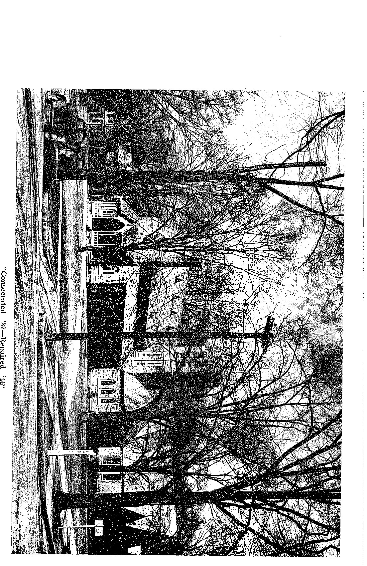

YEARS OF GRACE

Vlll
War and Peace
No minister had stepped into the bishopric from the clergy
stalls of Grace Church until 1942 when the Reverend James M. Stoney was called by the House of Bishops to be the shepherd of the Missionary District of New Mexico and Southwest Texas. Grace Church's only other rector to become a bishop was the Reverend John D. Wing.
On April 16, 1942, in the presence of a thousand friends,
Bishop Stoney was consecrated at the Church of St. Michael and All Angels. The consecrating bishops were the Rt. Reverend Henry St. George Tucker, Bishop of Virginia and Presiding Bishop, Charles C. J. Carpenter, Bishop of Alabama, R. Bland Mitchell, Bishop of Arkansas, Charles Clingman, Bishop of Kentucky, Edmund P. Dandridge, Bishop of Tennesssee, and Richard A. Kirchhoffer, Bishop of Indianapolis.
People started to arrive long before the prelude of the chimes began. The bells had never surnmoned a more responsive congregation since their first call to worship on Christmas Eve midnight, 1890. Clergymen of the Diocese, Vestrymen of Grace Church and St. Michael's, friends from the missions, visitors from out of town and Annistonians crowded into the spacious church.
A Consecration Service is designed like a great drama, and the music adds materially to the effect. Hardly a person remained unmoved when Mrs. Stoney sang Schelley's ''The King of Love My Shepherd Is" while her husband stood before the altar.
After the Consecration everyone was invited to Grace Church Parish House were the Junior Guild served a luncheon. The Guild had been busy for weeks preparing for the festivities connected with the Consecration. They made it a worthy occasion.
When Bishop Stoney left for New Mexico the Vestry called to Grace Church his brother, the Reverend William S. Stoney. He was presented the following picture of the situation:
The rectory was rented out and had to be recovered and renovated from top to• bottom. It had been' out of parish hands for eight years and needed extensive repair. In spite of a new roof the kitchen and study leaked. Colored tenants occupied the servant's house at the rear.
In, 1941 the United Service Organization-Young Women's Christian Association had been looking for a place in which to open for soldiers and their wives a "home away from home." Members of the parish worked out a scheme with the representative of the YWCA whereby the -organization should take over thé Parish House for week days and Sunday evenings at a small rent. The pressing need for room made the plarf seem a good one. The rapid expansion of Fort McClellan, howeoer, brought crowds of army wives •and children who overran the Parish House. They cooked, washed and ironed clothing, sewed, and all but slept in the building. In the evenings they played games, danced, chatted and wrote letters.
•Agreements with the Parish about sharing the building for Sunday School and other organizations were necessarily abandoned and forgotten by the changing personnel. The Parish House roof was leaking, with plaster falling from time to time.
The roof of the church was leaking, too. Pigeons inhabited the tower and a broken cross stood over the little wooden porch. The vacant lot had grown up in tall grass.
So this was war!
That was a busy summer. The lodgers moved out of the Rectory. At three o'clock one moining the new rector arrived in town .on his load of furniture. Nobody was astir. By the time the. Parish waked up he had unloaded the furniture through a door unwittingly left open at the Rectory.
Then began sanding, papering, painting, repairing, while the rector livéd from room to room and from home to home among the parishioners.
There was no place to develop the parish program, The little Vestryroom-Sacristry at- the tower of the church had to be pressed into multiple service.. It became the meeting place for Boy Scouts, the choir, YPSL, the •Auxiliary and the Guilds when all these were crowded out of the Parish House. It also served as c.hurch office and part of the Sunday School. And its roof leaked, too.
A little relief was brought about when the USO agreed to cement the basement of the Parish House. That gave a home to the Boy Scouts and the Navy Mothers and a laundry room to the army wives. It is suspected that many old records were lost when the basement was cleared of its accumulation of ages. And the new leaked!
Meanwhile members of the parish were greeting soldiers at church door, chatting with them and taking them home for Sunday dinners. Visits usually lasted all afternoon and far into the evening until those precious hours of leave were exhausted —and often the hostess, too. But many a Sunday morning service was brightened by the presence of extra choir members and worshippers from the Fort.
War marriages created great interest. The parish women frequently helped with ceremonies and the church provided wedding marches, altar flowers and sympathetic witnesses for brides and grooms far away from home.
In the summer of 1942 the Vestry passed a resolution which led ultimately to the closing of all the missions. At the same meeting the Vestry requested the rector to concentrate his efforts on developing the parish work.
Because of war conditions Noble Arms, which for sorne time had been rented out, was overcrowded and infested with roaches and rats. The Vestry had received warnings that the building was a fire hazard and below Public Health standards. When a purchaser offered them a good price, the harassed Vestry sold the Arms.
Then, one day, the war was over. The men came home. Grace Church had not lost a single man. In gratitude, Gambrell N. McCarty placed near the entrance to the church a bronze plaque on which the names of the veterans were engraved.
Quietly the women had organized into an all-inclusive Woman's Auxiliary. They moved into the Parish House the day the USO moved out. Complying with their request to stop leaks and patch plaster, the Buildings and Grounds comrnittee of the Vestry replaced the old slate roof with a temporary but tight one. Then came busy days of painting, cleaning, and renovating.
One after another of the parish organizations fitted their work into the new scheme. While the rector was away on vacation the Auxiliary converted the library of the Parish House into a study for him. The Sunday School moved back into the Parish House, So did the YPSL. A place was provided for a choir director's studio where the choir could rehearse.
The parish life responded to the new surroundings.
In the spring of 1946 a nationwide Reconstruction and Advance Fund drive was underway. Its purpose was to restore churches, schools and hospitals destroyed by war. To plan participation in this campaign, the Reverend William S. Stoney invited thirty parishioners to a supper meeting at the Rectory. The group worked out a simple yet thorough plan whereby each solicitor had to make about five calls on the congregation members. The campaign was popular; the visits in the homes of the parishioners were pleasant; the responses were cheerful and generous. The following week the group reassembled to report that the $2500 quota had been not only reached but over-subscribed.
For years Every Member Canvasses had been burdens to the chairmen and the rector. The campaigns were drawn out over weeks of tedious soliciting. But here was a quick and cheerful way of making a complete canvass of every member of the parish. The 1946 chairman of the Every Member Canvass was one of the thirty. He followed a similar plan that fall and made an audacious request to the members of Grace Church to double their subscriptions. He proposed the slogan: "Grace Church, Consecrated 1886, Repaired 1946." The campaign was successful. Another turning point in parish life had been passed.
Then the Vestry worked its way through months of planning and debating to arrive at a decision on a roof for the church. Interstate Roofing Company of Anniston took the contract under the direction of Warren, Knight and Davis, Architects, of Birmingham. Thick variegated slate was ordered from Rising and NOIson of Vermont—the best that could be had. The green, brown and red colors are arranged on the roof so as to give a sense of blending with the sky.
In connection with the Feast of Lights service, the roof was dedicated on the Second Sunday after the Epiphäny, 1948. It had been hoped that the dedication could be held outside, but the weather was so cold that the congregation remained in the warrn church for the simple service. As the rector finished speaking of the work on the roof the Senior and Junior Wardens came to his side. The members of the Buildings and Grounds Committee stepped forward and presented the completed plans and specifications to the rector who turned then over to the Wardens, the -official keepers of the church propeffy. The Feast of Lights Service followed.
The new roof completed, the Parish House redecorated, the 1947 Every Member Canvass nearly a thousand dollars oversubscribed, the 1948 Annual Parish Meeting reflected a picture of a parish program back on its peacetime basis. Looking forward to new accomplishments, the rector appointed a cornmittee of Grace Church veterans to study erecting for the church the permanent stone porch which the original planners dreamed of.
Isreal could not turn • back. To turn to the right or to the left was out of the question, because of the deserts. Behind them was Pharoah's army. Before Moses and the people stretched the waters of the Red Sea. The people cried out for help. Moses asked God what could be done. God said to Moses, "Tell my people, Israel, that I say 'Go Forward.'
YEARS OF GRACE
CHART OF GIFTS
ALMS BASINS: Wooden basins were given by the first rector, Reverend Wallace Carnahan.
Silver basins were given by Lida Tunstall (Mrs, Richard Hooker) Cobbs as a memorial to her husband.
Large brass receiving basin was given by Daughters of the King in memory of Ellie Shepperd (Mrs. Alfred Pelhåm) Agee.
ALTARS: Given by Mr. Carnahan and ladies of the congregation (See Chapter Ill, page 18).
BAPTISMAL ITEMS: Large ewer given in 1903 by little girls in sunday School class of Minnie Parker (Mrs. T. K.) Scott. Their names are inscribed on it: Annie Scott Tyler, Nellie Osgood Tyler, Gertrude Hambleton Shepperd, Mary Clifton Roberts, Susie Ball Allen, Christine Noble McCaa, Emily Tyler Kelley, Angela Woodward Marshall, Lucy Mason Tyler, Anne Horry Kilby, Mary Evelyn Scott, Augusta Hobson Cobbs, Elizabeth Willett, Sarah Agnes Keith, Melanie Wilmer Gordon, Phebe Mosgrove Colwell.
Bowl. for private baptisms given by Elbert Henry Willett in 1917 in memory of his wife, Lucy Tyler Willett, after it had been used to christen their baby, Lucy Tyler Willett (who became Mrs. Harold Calhoun Stanley.)
BOOKS: Bible on lectern given by Governor Thomas Erby Kilby .in memory of Aug. Henry Shepperd. Governor Kilby also gave the prayer book on the prie dieu and thé missal on the Communion Table.
First missal was given by the Senior Guild in memory of Anna Rittman (Mrs. Max Franz) Doering.
Prayer book on litany desk was given by Lucia Johnson (Mrs. Joseph Henry) Edmondson in memory of her mother-in-law, Sarah Brown Edmondson.
Hymnal on prie-dieu was given by Mrs. Hiram K. Regar.
New hymnals were given in 1945 by Mrs. J. H. Edmondson, inscribed to the memory of Richard Hooker Cobbs.
CANDLESTICKS: Eucharistic candlesticks were given by Belle Webb (Mrs. Edmund Leighton) TYIer in memory of her husband.
Pair of triple candlesticks for the altar given in May, 1945, by Thomas Scott Roberts in memory of Clifton Roberts (Mrs. James Moss) Stoney and Augusta Cobbs (Mrs. Charles A.) Poellnitz.
CHAIRS: Bishop's Chair was given by "Ten Minute Society" directed by Mrs. T. K. Scott, Mrs. Whetstone and Miss Margaret Brewer. (See Chapter Vil, page 37).
Rector's Chair (inside chancel rail) given in 1902 by children of St. Alban's Guild let by Mrs. W. T. Edmondson.

Rector's reading desk chair (outside chancel rail) was given by Grace Church Parish Guild in memory of Mrs. E. L. Tyler. It was designed by a member of the Guild, Ratebelle Kilby (Mrs. Frank M.) Coleman.
CHANCEL RAIL: Given in October, 1903, in memory of Duncan T. Parker and Cornelia A. Parker by their daughter Susie Parker (Mrs. W. W.) Stringfellow.
COMMUNION VESSELS: Chalice, paten and flagon were given by Alfred Lee and Annie E. Tyler in 1887.
Lavabo (inscribed "Holmes Johnson") by Mrs. J. H. Edmondson in memory of her father.
One cruet by Mary Clark (Mrs. Thomas Erby) Kilby in memory of her mother on Easter, 1904.
The other cruet by Max Franz Doering, Easter, 1904, Bread box inscribed "Easter, 1906," unknown donor.
CROSSES: Altar cross in memory of General Daniel Tyler by his daughter, Mrs. Alexander Moore.
Processional cross by Sunday School children in 1902. (See Chapter VII, pg. 37). The cross was selected by Minnie Parker (Mrs, F. E,) Hagemeyey.
FLAGS: Silk United States flag by Anne Tyler (Mrs. William Hornbeek) Deyo in 1942.
Silk church flag by Mr. and Mrs. Richard H. Cobbs in 1942.
Service flag for World War 11 by Mr. and Mrs. Gambrell N. McCarty in •1944.
FONT: Given by E. L. Tyler and niece, Emily Caroline Tyler (Mrs. William Darrah) Kelley.
HANGINGS: First white hangings, embroidered with blue lilies, in memory of Mrs. Samuel Noble by her daughters, Mrs.- E, E. G. Roberts, Mrs. William Lowndes McCaa and Mrs. James Keith.
Second white hangings' by Grace Church Parish Guild in memory of Mrs. Hambleton Shepperd, mother of A, H. Shepperd. Selected in New York by Mrs. Richard H. Stickney.
Green hangings given by Senior Guild as a memorial to Mr. and Mrs.
Max Franz Doering. Obtained in China by Josephine Nourse (Mrs. C. A.) Smith} while her husband was stationed there.
Red and purple hangings were given by the Grace Church Parish Guild. LECTERN: Given i_n 1887 by Augustus Cleveland Tyler, youngest son of General Daniel Tyler.
LIGHTS: Cross and star of lights were given by Thomas E. Kilby, Jr.
IVÆMORIALS: Whitfield in investments.
Noble—$21,227.24 in investments.
Shepperd—$2,189.00 in investments.
in real estate investments (See Chapter I, page 2)
Gratitude Fund—(individual contributions in gratitude that no Grace Church veteran was killed in World War Il, established to erect suitable porch) $235.17.
Kelley—(To erect suitable poréh) cash deposit of $1,250.00.
ORGANS: First organ given by John Ward Noble. Built by Henry Pileher & Son of Louisville, Kentucky. Electric motor was installed in 1907, Alfred Lee Tyler, Sr., paying half the cost.
Second organ was bought by the Vestry from Henry Pilcher & Son in 1918.
PLAQUES: Bronze bas-relief portrait of General Daniel Tyler given by his family was executed by Augustus Saint Gaudens.
Alfred Lee Tyler, Sr., memorial plaque given -by his children in 1908. Gratitude Plaque at church entrance given by Gambrell N. McCarty (See Chapter VIE),
PRIE-DIEU: Given by Mrs, W. W. Stringfellow, inscribed "Thank •Offering."
PULPIT: Given by Mrs. A. L. Tyler, sr.
VASES: Small altar vases given by Mrs. Alexander Moore in memory of her father, General Daniel Tyler.
Large brass altar vases given by Lucy Tyler Willett (Mrs. Harold Calhoun) Stanley in memory of her parents, Mr. and Mrs. E. H. Willett.
WINDOWS: Altar window depicting Christ among the lilies given by women of the congregation (See Chapter IV).
Gorham Epiphany window -given in memory of Samuel Noble by his family. Dedicated in 1915 on his birthday, November 22.
Window to west of altar given by Mrs. Alfred Lee Tyler, Sr., in memory of her husband in 1910.
Madonna window given by Mr. and Mrs. A. L. Tyler, Sr., in memory of their infant grandson, Alfred Lee Tyler, Ill, in 1906.
Window inscribed "Remember now thy Creator in the days of thy youth" was given by a Sunday School class of Carrie Tyler (Mrs. William Darrah) Kelley.
Window depicting Christ blessing the children (east of church) given by Senator and Mrs. Maximilian Bethune Wellborn in memory of their children Minna Dent, Maximilian Bethune and Iverson Graves.
Choir window given by the widow and children of Joseph Henry Edmondson in memory of him and his mother, Sarah Brown Edmondson.
Wi.ndow depicting Christ with the children (west of church) given in 1929 by Captain Alfred Pelham Agee in memory of his wife, Ellie Shepperd Agee, and their children, Roberta and John Shepperd.

