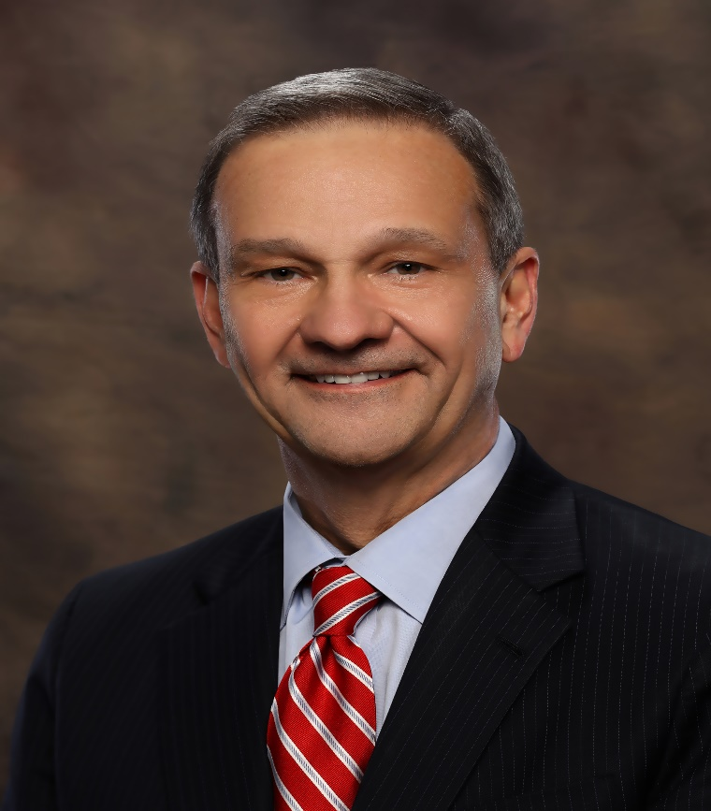

Previous Experience:

Member 2002 – 2014 Served as Sunday School Teacher, Lector, EM & in Choir.
Attended Cursillo and completed EFM Program. Delegate to Bishop Suffragan Election. Previous service on Vestry and as Jr. Warden and Sr. Warden.

Current Experience:

Returned as a Member in 2022. Serves as Lector & in Choir.

Occupation:

Estate & Probate Attorney

