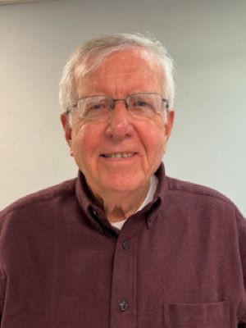
Family: Perry H. Reynolds
Marilyn Reynolds
Chris Reynolds, Amber Reynolds, Reid Reynolds Ross Reynolds
Andrew Reynolds, Jen Reynolds, Belle Reynolds, Greyson Reynolds
Length of Time at Grace Church:
I am 1 of 3 oldest cradle Grace Church Episcopalians I was Baptized and Confirmed at Grace Church
Why I came to Grace Church:
Parents brought me to church
My favorite thing about Grace Church:
The good people of Grace Church. The history of Grace Church. The love Each other
My parish activities:
I have served on more Vestries than I can remember. I have served as
Junior Warden, Senior Warden. I have headed four Search Committees. I have led several Sunday School Classes. I currently serve on a breakfast team. I have served as a Lay Eucharist Minister. I currently serve as a Lay Reader. Years ago, I led Morning Prayer during the week for a short period of time.
Professional History:
Plant Superintendent John Harland Company
Plant Manager John Harland Company
Owner & Agent Dormon & Reynolds Insurance, Inc.
Other Interest:
My newest interest is Quantum Theory and the cosmos
Why I would like to serve as a Vestry Member?
To help Grace Church through the obstacles that are ahead of us

