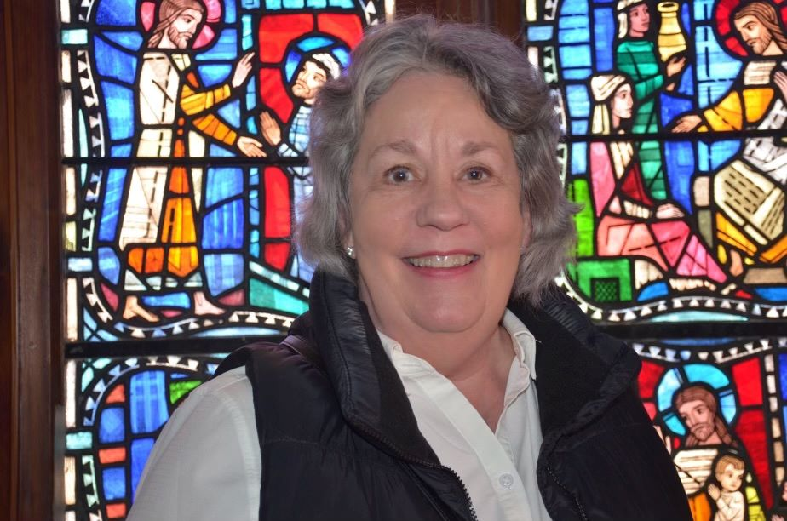

Donna Plummer

Family: Two (2) daughters, four (4) Grandchildren

Length of Time at Grace: Since 1984 (39 years)

Why I came to Grace: I found a church I could grow in my faith.

My favorite thing about Grace Episcopal Church: The people, my family.

My Parish Activities: Most recently; DOK, ECW Board and Choir.

If applicable, experiences at other churches: Vestry (in Indiana), head of Sunday School programs, led Alpha Program in Illinois, Choir.

Professional History: Speech Pathologist (Retired)

Other Interests: Playing Bridge, mahjong and traveling.

Why I would like to serve as a Vestry Member: To Support Father Wally and the growth of the church.

